Scan in Travel
Software Requirement Specification

By
Yirui Wang 542115509
Ruijuan Liu 542115508

Department of Software Engineering
College of Arts, Media and Technology
Chiang Mai University

Project Advisor

Yun Rim Park

Document History
Document Name | Version | Status | Date | Viewable | Editable | Responsible
Documents
Scan in Travel _Software Requirement Specification | Software Requirement Specification_V1.0 | Reviewed | 28-05-2014 | Yun Rim Park  Yirui Wang  Ruijuan Liu | Yirui Wang  Ruijuan Liu | Yirui Wang  Ruijuan Liu
Scan in Travel _Software Requirement Specification | Software Requirement Specification_V1.1 | Reviewed | 24-07-2014 | Yun Rim Park  Yirui Wang  Ruijuan Liu | Yirui Wang  Ruijuan Liu | Yirui Wang  Ruijuan Liu
Scan in Travel _Software Requirement Specification | Software Requirement Specification_V2.0 | Reviewed | 28-07-2014 | Yun Rim Park  Yirui Wang  Ruijuan Liu | Yirui Wang  Ruijuan Liu | Yirui Wang  Ruijuan Liu

Document Approved by

Yun Rim Park

Table of Contents

Chapter One | Introduction........................…….…………………………..…5
1.1 Objective………………......……......…......................……………..5
1.2 Intended Audience and Reading Suggestions......................………..5
1.2.1 Development team..............................………………..….....…5
1.2.2 Customer..............................……...............…………..….....…5
1.3 Project Scope…………….............…...........................……………..6
1.4 Acronyms and Definitions................……...................…….………..7
1.4.1 Acronyms.......................................……………………….....…7
1.4.2 Definitions......................................……………………….....…7

Chapter Two | Overall Description…................….…………………………..9
2.1 Product Perspective……......................…….….......................……..9
2.2 Product Features.......………….....……...……......………...…….…9
2.3 User Classes and Characteristics......……....…......………...……….9
2.4 Operation Environment......……....…......………...….............……..9
2.5 Design and Implementation Constrains.….......…...….................…10

Chapter Three | Functional Requirement………..…….…………...……….11
3.1 User Requirement Specification..............................……....…….....11
3.2 User Requirement Specification with the Software Requirement Specification.......................……..........................................……..13

Chapter Four | Specific Requirement……......................…………..….……30
4.1Use Case Scenarios ……..…..………………...…………….…......30
4.1.1 Use Case Diagram (Entire System)…......………………….…30
4.1.2 Use Case Diagram (Translation System)........…..………….....31
4.1.3 Use Case Diagram (Map System)…....….………………….....31
4.1.4 Use Case Diagram (Favorite System)…....…...…………….....32
4.1.5 Use Case Diagram (Word book System)…......…...…………...33

4.2 Use Case Description…….....……………….....………………….34
4.2.1 Feature Name (Translation System).....................………….....34
4.2.1.1 Feature Process Flow..............................................….....34
4.2.1.2 Use Case(s).............................................................….....34
4.2.2 Feature Name (Map System)................................………….....45
4.2.2.1 Feature Process Flow..............................................….....45
4.2.2.2 Use Case(s).............................................................….....45
4.2.3 Feature Name (Favorites System).......................……..…….....59
4.2.3.1 Feature Process Flow..............................................….....59
4.2.3.2 Use Case(s).............................................................….....59
4.2.4 Feature Name (Word book System)......................………….....95
4.2.4.1 Feature Process Flow..............................................….....95
4.2.4.2 Use Case(s)...........................................................….......95

Chapter Five |Reference……….….............…...............…………………..112

Chapter One | Introduction

1.1 Objective

The objective of the Software Requirement Specification document is to outline all the requirements for “Scan in Travel” application. Clearly and accurately describes each of the essential requirements (functions, performance and design constraints) of the system and its external interfaces. This document is based on the project proposal and project plan. It also contains a general description of the types of users who will be using or application, how it is going to work, and goals.
This document is intended to be used by the members of the project team and other stakeholders who will participate in the design and implementation phases of the project and verify the correct functionality of the system. And the application will be designed following this document.

1.2 Intended Audience and Reading Suggestions

This Software Requirement Specification is created for everyone involved with the “Scan in Travel” application. It will make benefits for people as follows:

1.2.1 Development team
·Help every member of development team have a good understanding about the
requirements and how it is going to work.
·Reduce the development effort.
·Provide a basis for validation and verification.
·Avoid error in work. Verify and specify all requirements to ensure the same
understanding about the requirements

1.2.2 Customer
·Help customers to accurately describe what they wish to obtain.
·Establish the basis for agreement between the customers and the development team on what the application is to do.

1.3 Project Scope

“Scan in Travel” is a mobile application which uses Android OS. This application can help users solve the language problems during their travel in China. Users can get the meaning of Chinese word(s) by scanning it with the built-in camera of their mobile phone. And users can also get the map and route if the scanned name is the name of a Location (Chinese word that has its location on the Google map) in China. What is more, “Scan in Travel” can also help users remember where they have been. Users can record the attractive places into their Favorites so that they can look them up later.
The main features of “Scan in Travel” will be as follows:

Translation system
Users can translate Chinese word(s) and Location name(s) into English by scanning them with the built-in camera of their mobile phone. After viewing the English translation of the word(s), users can also select the text-to-speech function to listen to the pronunciation of the Chinese word(s). Moreover, users can edit the Chinese word(s) that are scanned to get new explanation in English.

Map system
Users can scan a Location name and find where it is located on a map. The system will guide users to get to the Location by providing a route on a map. Besides, users can keep their own map of every Location in their Favorites (see below for details). The system lets users see every saved Location on a map, and check the details of each Location.
Favorites system
After users scan a Location name, they can save the Location with its name both in Chinese and English, pictures, geometry information (i.e. latitude and longitude), and descriptions into their Favorites. Users can add the picture of the Location from their own gallery and write down their own description for it. Moreover, users can select to sort Locations in their Favorites alphabetically, sort Locations by province and sort Locations by date also. Meanwhile, users can search Locations by English keyword.
Word book system
Once users get the English meaning of the scanned Chinese words, they can save the scanned words with English translation to their own Word book. When users are viewing the word list in their Word book, they can sort the words alphabetically or by date when words are added. Users can also search the words by keyword related to their English meaning. Moreover, users can select the text-to-speech function to listen to the pronunciation of the selected Chinese word(s). Moreover, users can make their own note to each word that they save in their Word book.

1.4 Acronyms and Definitions

1.4.1 Acronyms
SRS Software Requirement Specification
URS User Requirement Specification

1.4.2 Definitions
Feature Transformation of input parameters to output parameters based on a specified algorithm. It describes the functionality of a product in the language of the product. Used for requirements analysis, design, coding, testing or maintenance.

User interface User interface (UI) is everything designed into an information device with which a human being may interact including display screen, keyboard, mouse, light pen, the appearance of a desktop, illuminated characters, help messages, and how an application program or a Web site invites interaction and responds to it.[1]

UML The Unified Modeling Language (UML) is a general -purpose modeling language in the field of software engineering, which is designed to provide a standard way to visualize the design of a system.[2]

Activity diagram Activity diagrams are graphical representations of workflows of stepwise activities and actions with support for choice, iteration and concurrency. Activity diagrams show the overall flow of control.[3]

Use case A use case is a methodology used in system analysis to identify, clarify, and organize system requirements. The use case is made up of a set of possible sequences of interactions between systems and users in a particular environment and related to a particular goal. It consists of a group of elements (for example, classes and interfaces) that can be used together in a way that will have an effect larger than the sum of the separate elements combined.[4]

Use case diagram A use case diagram at its simplest is a representation of a user's interaction with the system and depicting the specifications of a use case. A use case diagram can portray the different types of users of a system and the various ways that they interact with the system.[5]

Chapter Two | Overall Description

2.1 Product Perspective
“Scan in Travel” is an Android application that uses the built-in camera of a mobile phone to capture the image of a Chinese word, converts that image into text, and translates it into English. Tourists can understand the meaning of the word in text and listen to how it is pronounced in Chinese.
“Scan in Travel” can also use the build-in camera to capture the image of a Location name, and provide the map of the place to help users get to the Location.
In addition, “Scan in Travel” application provides a function to help tourists remember where they have been. Tourists can save the Locations with pictures, descriptions and geometry information (i.e. latitude and longitude) in their Favorites list. It can help tourists record their trip and help them easily return to those Locations they have visited before.

2.2 Product Features
According to the architecture of our project and the time schedule of senior project, we separated the whole implementation period to two progress and four main features. The description is shown below:
Progress I:
Feature #1 Translation system
Feature #2 Map system
Feature #3 Favorites system

Progress II:
Feature #4 Word book system

2.3 User Classes and Characteristics
The intended users for this application are the tourists who want to travel in China. Foreign tourists might face the language barriers or other problems while traveling in China. They have to have basic English skills to use “Scan in Travel” application.

2.4 Operation Environment
• Laptops
-- ASUS K43E
Processor: Intel(R) Core(TM) i5-2410M CPU @ 2.30GHz
Memory: 6.00 GB
Graphics: Intel(R) HD Graphics 3000
Operating System: Window 7 Home Basic

-- Dell Inspiron M4010
Processor: AMD Athlon(tm) ⅡP360 Dual-Core Processor @ 2.30 GHz
Memory: 6.00 GB
Graphics: ATI Mobility Radeon HD 5430
Operating System: Windows 7 Ultimate

• Internet

• Mobile phone: Android Operating System
-- Samsung GT-I9100G
CPU: ARMv7 Processor rev 3 (v7I) Dual-core @ 1.2 GHz
Memory: 1.97 GB
Operating System: Android OS version 4.0.4

-- LG Nexus 5
CPU: Snapdragon 800
Memory: 2 GB
Operating System: Android OS version 4.4.2

2.5 Design and Implementation Constrains
• Developers have to consider about density, size, feature, and hardware from different mobile devices.
• Overload data might effect to the application because mobile device has slow CPUs and limited memory.

Chapter Three | Functional Requirement

3.1 User Requirement Specification
Feature #1 Translation system
URS-01: Users can scan Chinese words and Location names by using built-in camera.
URS-02: Users can view the explanation (i.e. meaning, pronunciation) of the scanned word(s) in English.
URS-03: Users can select Text-to-Speech to get the Chinese pronunciation of the word.
URS-04: Users can edit the Chinese word(s) (or Location name(s)) that are scanned to get the new explanation in English.

Feature #2 Map system
URS-05: Users can get the Locations list including Locations related to scanned word with the Location name both in Chinese and English.
URS-06: Users can select one Location from Locations list which is related to the scanned word(s) to view its location on map.
URS-07: Users can view the map that shows the route from the current position to the selected Location from Locations list which is related to the scanned word(s).
URS-08: Users can view all Locations related to scanned word(s) on one map.
URS-09: Users can view all Locations from their own Favorites on the map.
URS-10: Users can view the map that shows the route from the current position to a Location selected from their own Favorites.

Feature #3 Favorites system
URS-11: Users can add the selected Location from Locations list which is related to the scanned word with its Chinese name, English name, pictures, geometry information (i.e. latitude and longitude), and Location descriptions into their Favorites.
URS-12: Users can view a list of Locations with their Chinese name, English name and added date in their own Favorites.
URS-13: Users can select one Location from Favorites to view its information with Chinese name, English name, pictures, geometry information (i.e. latitude and longitude), and Location description in their Favorites.
URS-14: Users can select Text-To-Speech to get the pronunciation of the Location name in Chinese from their own Favorites.
URS-15: Users can edit the Location information with English name, pictures and Location description in their own Favorites.
URS-16: Users can delete a Location from their own Favorites.
URS-17: Users can view a Location on the map from Favorites list.
URS-18: Users can sort the Locations in Favorites by date when they are added.
URS-19: Users can sort the Locations in Favorites by province name to get a list of province names.
URS-20: Users can select one province to view the Locations list in that province.
URS-21: Users can sort the Locations list related to one province by date.
URS-22: Users can sort the Locations list related to one province alphabetically.
URS-23: Users can search province by English keyword in the province list.
URS-24: Users can search Location by English keyword in the Locations list related to one province.
URS-25: Users can search Locations by English keyword from all the Locations in their Favorites.
URS-26: Users can view the home page.

Feature #4 Word book system
URS-27: Users can add the scanned words into their own Word book.
URS-28: Users can view a Chinese word list with its English meaning and added date in their Word book.
URS-29: Users can select one Chinese word from word list to view the Chinese words and related information.
URS-30: Users can select Text-To-Speech to get the pronunciation of a Chinese word in their Word book.
URS-31: Users can delete a word from their own Word book.
URS-32: Users can sort the words in their Word book by date when they are added.
URS-33: Users can sort the words in their Word book alphabetically.
URS-34: Users can search Chinese words in the Word book by their meaning in English.
URS-35: Users can make their own note to each word in their Word book.
URS-36: Users can view help information.

3.2 User Requirement Specification with the Software Requirement Specification
URS-01: Users can scan Chinese words and Location names by using built-in camera.
SRS-01: System shall invoke the built-in camera of users’ mobile phones.
SRS-02: System shall provide user interface for users to scan Chinese words (or Location names) by using built-in camera.
SRS-03: System shall provide user interface for users to inform that system can recognize simplified Chinese now.
SRS-04: System shall provide instructions “Please focus on one line. You can use finger to change the scanning box.” for users to tell them how to scan Chinese words.
SRS-05: System shall capture the image of the scanned Chinese words (or Location names).
SRS-06: System shall recognize the Chinese words（or Location names) and convert the image into searchable text of the scanned Chinese words (or Location names).
SRS-07: System shall provide the service for users to change the horizontal size of scan box.
SRS-08: System shall provide the user interface to display the error message. “Could not initialize camera. Please try restarting device.”
SRS-09: System shall not get anything about the searchable text of the scanned image.
SRS-10: System shall display some unrecognizable, broken letters or nothing below the scan box.

URS-02: Users can view the explanation (i.e. meaning, pronunciation) of the scanned word(s) in English.
SRS-11: System shall provide a control (e.g. button) for users to choose to get the explanation of the scanned word.
SRS-12: System shall receive the request from users to get the explanation of the scanned word.
SRS-13: System shall send the text of the scanned Chinese word (or Location name) to Microsoft Translator API.
SRS-14: System shall receive the explanation (i.e. meaning, pronunciation) of the scanned word in English from Microsoft Translator API.
SRS-15: System shall provide the user interface to display the image of scanned word, the text of the Chinese word and the meaning of the scanned word in English.
SRS-16: System shall provide a control (e.g. button) for users to choose to return the user interface which users can scan the Chinese words.
SRS-17: System shall receive the request from users to return to the user interface which users can scan the Chinese words.
SRS-18: System shall return to the user interface which users can scan the Chinese words and the scanning function will be available.
SRS-19: System shall provide the user interface to display the error message. “No internet connection.”
SRS-20: System shall provide the user interface to display the image of scanned word and the recognized text of the Chinese word only.
SRS-21: System shall provide a user interface to show the error message: “Scan failed. Please try again.”
SRS-22: System shall provide the user interface to display the image of scanned word, the recognized text of scanned word and the translation of recognized text which is same as the recognized text.

URS-03: Users can select Text-to-Speech to get the Chinese pronunciation of the word.
SRS-23: System shall provide a control (e.g. Button) on the interface for users to get the proper Chinese pronunciation of the scanned word.
SRS-13: System shall send the text of the scanned Chinese word (or Location name) to Microsoft Translator API.
SRS-24: System shall receive the pronunciation of the scanned word in Chinese from Microsoft Translator API.
SRS-25: System shall pronounce the word to users in Chinese.
SRS-26: System shall pronounce the Chinese text to users in Chinese, English character in English.
SRS-27: System shall pronounce the Chinese text to users in Chinese, numbers or punctuations in Chinese as well.
SRS-19: System shall provide the user interface to display the error message. “No internet connection.”
SRS-28: System cannot provide the Chinese pronunciation to users.

URS-04: Users can edit the Chinese word(s) (or Location name(s)) that are scanned to get the new explanation in English.
SRS-29: System shall provide a control (e.g. Button) on the interface for users to select to edit the text of the scanned Chinese word(s) (or Location name(s)).
SRS-30: System shall provide the user interface for users to edit the text of scanned Chinese word(s) (or Location name(s)).
SRS-31: System shall provide a control (e.g. Button) on the interface for users to indicate that editing is completed.
SRS-32: System shall provide the user interface to display the error message: “Text length should not be more than 50.”
SRS-33: System shall provide the user interface to display error message: “Text length should not be empty.”
SRS-34: System shall return to the user interface for scanning Chinese words (or Location names).
SRS-19: System shall provide the user interface to display the error message. “No internet connection.”
SRS-35: System shall provide the user interface to display the image of scanned word and the text of the edited Chinese word only.

URS-05: Users can get the Locations list including Locations related to scanned word with the Location name both in Chinese and English.
SRS-36: System shall provide a control (e.g. Button) on the interface for users to select to get the map of the scanned Location name(s)).
SRS-37: System shall receive the request from users to get the map of the scanned word.
SRS-38: System shall send the text of the scanned Chinese word (or Location name) to Google Maps API.
SRS-39: System shall receive the related Location list (including Chinese Location name, English Location name) of the scanned word from Google Maps API.
SRS-40: System shall provide the user interface for users to show the list of Locations related to scanned word with the Location name both in Chinese and English.
SRS-41: System shall provide the user interface to display the error message: “No location related to the scanned word or no internet connection.”

URS-06: Users can select one Location from Locations list which is related to the scanned word(s) to view its location on map.
SRS-42: System shall provide a control for users to select one Location from related Locations list to get the map of this Location.
SRS-43: System shall receive the request from users to get the map of the Location.
SRS-44: System shall send the geometry information (latitude and longitude) of the selected Location to Google Maps API.
SRS-45: System shall receive the map of the selected Location from Google Maps API.
SRS-46: System shall provide the user interface for users to show the map of selected Location with marker.
SRS-47: System shall provide a control (e.g. button) to users to return to the previous related Locations list.
SRS-19: System shall provide the user interface to display the error message. “No internet connection.”
SRS-48: System shall provide the user interface to display an empty map.

URS-07: Users can view the map that shows the route from the current position to the selected Location from Locations list which is related to the scanned word(s).
SRS-49: System shall provide a control (e.g. button) for users to choose get route from current position to selected Location.
SRS-50: System shall receive the request from users to get the route from current position to selected Location.
SRS-44: System shall send the geometry information (latitude and longitude) of the selected Location to Google Maps API.
SRS-51: System shall use Global Position System to get the current position of users.
SRS-52: System shall send the current position geometry information (latitude and longitude) of users to the Google Maps API.
SRS-53: System shall receive the route information from the current position to the Location selected by users from related Locations list.
SRS-54: System shall provide the user interface to display the markers of the users’ current position and the selected Location on the map.
SRS-55: System shall provide the user interface to display the route from the current position to the Location selected by users from related Locations list on the map.
SRS-56: System shall provide the user interface to display the error message. “Please open your GPS service to allow Google Map to get your location.”
SRS-47: System shall provide a control (e.g. button) to users to return to the previous related Locations list.
SRS-19: System shall provide the user interface to display the error message. “No internet connection.”
SRS-57: System shall show the error message: “No route”.

URS-08: Users can view all Locations related to scanned word(s) on one map.
SRS-58: System shall provide a thumbnail map to help users know the general position of related Locations on the map.
SRS-59: System shall provide the user interface to display all the related Locations on one map.
SRS-60: System shall provide a marker for each Location.
SRS-61: System shall provide an information window for users to show the Chinese Location name and English Location name of the clicked Location.
SRS-47: System shall provide a control (e.g. button) to users to return to the previous related Locations list.
SRS-19: System shall provide the user interface to display the error message. “No internet connection.”

URS-09: Users can view all Locations from their own Favorites on the map.
SRS-62: System shall retrieve all the Locations data in their own Favorites from database.
SRS-63: System shall send all the Locations geometry information (latitude and longitude) to the Google Maps API.
SRS-64: System shall provide a thumbnail map to help users know the general position of all Locations in their Favorites.
SRS-65: System shall provide the user interface for users to show the map of all Locations in the Favorites with markers.
SRS-60: System shall provide a marker for each Location.
SRS-61: System shall provide an information window for users to show the Chinese Location name and English Location name of the clicked Location.
SRS-47: System shall provide a control (e.g. button) to users to return to the previous related Locations list.
SRS-19: System shall provide the user interface to display the error message. “No internet connection.”
URS-10: Users can view the map that shows the route from the current position to a Location selected from their own Favorites.
SRS-49: System shall provide a control (e.g. button) for users to choose get route from current position to selected Location.
SRS-44: System shall send the geometry information (latitude and longitude) of the selected Location to Google Maps API.
SRS-51: System shall use Global Position System to get the current position of users.
SRS-52: System shall send the current position geometry information (latitude and longitude) of users to the Google Maps API.
SRS-66: System shall receive the route information from the current position to the Location selected by users in their own Favorites.
SRS-54: System shall provide the user interface to display the markers of the users’ current position and the selected Location on the map.
SRS-67: System shall provide the user interface to display the route from the current position to the Location selected by users in their own Favorites on map.
SRS-56: System shall provide the user interface to display the error message. “Please open your GPS service to allow Google Map to get your location.”
SRS-68: System shall provide a control (e.g. button) to users to return to the previous Location information page.
SRS-19: System shall provide the user interface to display the error message. “No internet connection.”
SRS-57: System shall show the error message: “No route”.

URS-11: Users can add the selected Location from Locations list which is related to the scanned word with its Chinese name, English name, pictures, geometry information (i.e. latitude and longitude), and Location descriptions into their Favorites.
SRS-69: System shall provide a control (e.g. button) for users to add the selected Location into Favorites.
SRS-70: System shall provide the user interface to receive the data from users to add the selected Location. The data includes Location English name, pictures and description information.
SRS-71: System shall provide the Chinese name, English name and geometry information of the selected Location for users.
SRS-72: System shall provide the user interface to display the updated information of Location.
SRS-73: System shall add the selected Location with its Chinese name, English name, pictures, geometry information, and description into database.
SRS-74: System shall provide the user interface to display the successful message “Location added successfully!”
SRS-75: System shall provide two controls (e.g. button) for users to view Favorites list page or return to Add Location page.
SRS-76: System shall provide the user interface to display the Favorites page with new Location.
SRS-77: System shall provide a control (e.g. button) for users to cancel the service of add the selected Location.
SRS-78: System shall cancel the service of add the selected Location.
SRS-79: System shall provide the user interface to display thumbnail pictures that they select to add for the selected Location.
SRS-80: System shall provide the user interface to display the detailed picture of the selected one.
SRS-81: System shall provide a control (e.g. button) for users to cancel the service of viewing detailed picture.
SRS-82: System shall return to previous adding page.
SRS-83: System shall provide a control (e.g. button) for users to delete the current picture.
SRS-84: System shall delete the current picture.
SRS-85: System shall provide the user interface to display the error message. “Location’s English name should not be more than 120 characters.”
SRS-86: System shall provide the user interface to display the error message. “Description should not be more than 1500 characters.”
SRS-87: System shall provide the user interface to display the error message. “The amount of pictures should not be more than 200.”
SRS-88: System shall provide the user interface to display the error message: “Location exists already”.

URS-12: Users can view a list of Locations with their Chinese name, English name and added date in their own Favorites.
SRS-89: System shall provide a control (e.g. button) for users to view the Locations list in their Favorites.
SRS-62: System shall retrieve all the Locations data in their own Favorites from database.
SRS-90: System shall provide user interface to display a list of Locations from Favorites with their Chinese name, English name and added date.
SRS-91: System shall provide the user interface to display the error message: “No Locations in Favorites”.
URS-13: Users can select one Location from Favorites to view its information with Chinese name, English name, pictures, geometry information (i.e. latitude and longitude), and Location description in their Favorites.
SRS-92: System shall receive the request from users to get the Location information of selected Location.
SRS-93: System shall retrieve the Location information of selected Location from database.
SRS-94: System shall provide the user interface for users to view the Location information with Chinese name, English name, pictures, geometry information and description of selected Location in their Favorites.
SRS-95: System shall provide a control (e.g. button) to users to return to the previous Locations list in Favorites.

URS-14: Users can select Text-To-Speech to get the pronunciation of the Location name in Chinese from their own Favorites.
SRS-96: System shall provide a control (e.g. button) for users to request for the proper pronunciation of the Location Chinese name in their Favorites.
SRS-97: System shall send the Chinese name of the selected Location to Microsoft Translator API.
SRS-98: System shall receive the pronunciation of the selected Location name in Chinese.
SRS-99: System shall pronounce the Location name to users in Chinese.
SRS-19: System shall provide the user interface to display the error message. “No internet connection.”

URS-15: Users can edit the Location information with English name, pictures and Location description in their own Favorites.
SRS-100: System shall provide a control (e.g. button) for users to edit the Location information of selected Location in Favorites.
SRS-101: System shall provide the user interface for users to edit Location information with English name, pictures and Location description.
SRS-102: System shall retrieve the selected Location data from database.
SRS-103: System shall provide the Chinese name, English name, pictures and geometry information of the selected Location for users. And allow users to edit English name, pictures and Location description.
SRS-104: System shall update the Location information of selected Location into database.
SRS-105: System shall provide a control (e.g. button) for users to cancel the service of editing the Location information.
SRS-106: System shall cancel the service of editing the Location information.
SRS-107: System shall provide the user interface to display thumbnail pictures are stored of the selected Location.
SRS-80: System shall provide the user interface to display the detailed picture of the selected one.
SRS-81: System shall provide a control (e.g. button) for users to cancel the service of viewing detailed picture.
SRS-108: System shall return to previous editing page.
SRS-109: System shall provide the user interface to display thumbnail pictures that they edit for the selected Location.
SRS-83: System shall provide a control (e.g. button) for users to delete the current picture.
SRS-84: System shall delete the current picture.
SRS-85: System shall provide the user interface to display the error message. “Location’s English name should not be more than 120 characters.”
SRS-86: System shall provide the user interface to display the error message. “Description should not be more than 1500 characters.”
SRS-87: System shall provide the user interface to display the error message. “The amount of pictures should not be more than 200.”

URS-16: Users can delete a Location from their own Favorites.
SRS-110: System shall provide a control (e.g. button) for users to delete a Location from their own Favorites.
SRS-111: System shall prompt users to confirm the deletion of a selected Location in their own Favorites.
SRS-112: System shall provide the user interface to display the prompt message. “Are you sure to delete this Location from Favorites?”
SRS-113: System shall retrieve the data of the selected Location in the database.
SRS-114: System shall delete the data of the selected Location from database.
SRS-115: System shall provide the user interface to display the Favorites list without deleted Location.
SRS-116: System shall provide a control (e.g. button) for users to cancel the service of deleting the selected Location.
SRS-117: System shall cancel the service of deleting the selected Location.
SRS-118: System shall return to the selected Location information page.

URS-17: Users can view a Location on the map from Favorites list.
SRS-119: System shall provide a control (e.g. button) for users to view the map of selected Location from Favorites list.
SRS-44: System shall send the geometry information (latitude and longitude) of the selected Location to Google Maps API.
SRS-45: System shall receive the map of the selected Location from Google Maps API.
SRS-120: System shall provide the user interface to display the selected Location on the map.
SRS-68: System shall provide a control (e.g. button) to users to return to the previous Location information page.
SRS-121: System shall provide a marker for the Location.
SRS-61: System shall provide an information window for users to show the Chinese Location name and English Location name of the clicked Location.
SRS-19: System shall provide the user interface to display the error message. “No internet connection.”

URS-18: Users can sort the Locations in Favorites by date when they are added.
SRS-122: System shall provide a control (e.g. button) for users to sort the Locations in Favorites by date they are added.
SRS-62: System shall retrieve all the Locations data in their own Favorites from database.
SRS-123: System shall sort all the Locations data from database by date they are added.
SRS-124: System shall provide the user interface to display a list of names of sorted Locations including both Chinese and English by date. Dates are displayed also and sorted from the latest to the earliest.
SRS-125: System shall provide the user interface to display error message: “No Locations in your Favorites.”

URS-19: Users can sort the Locations in Favorites by province name to get a list of province names.
SRS-126: System shall provide a control (e.g. button) for users to sort the Locations in Favorites by province name.
SRS-62: System shall retrieve all the Locations data in their own Favorites from database.
SRS-127: System shall sort all the provinces related to the Locations in the Favorites.
SRS-128: System shall provide the user interface to display a list of province names.
SRS-129: System shall provide a popup window to show the prompt message:” Locations sorted by province.”
SRS-130: System shall provide the user interface to show prompt message. “No provinces found in Favorites.”

URS-20: Users can select one province to view the Locations list in that province.
SRS-131: System shall provide the service (e.g. provides the picture for each province) for users to select one province that they want view the Favorites Locations list of the selected province.
SRS-132: System shall retrieve the Locations data related to the selected province in their own Favorites from database.
SRS-133: System shall provide a list of Favorites Locations related to the selected province from Favorites.
SRS-113: System shall retrieve the data of the selected Location in the database.
SRS-94: System shall provide the user interface for users to view the Location information with Chinese name, English name, pictures, geometry information and description of selected Location in their Favorites.
SRS-134: System shall provide a control (e.g. button) to users to return to the previous Favorites provinces list.

URS-21: Users can sort the Locations list related to one province by date.
SRS-135: System shall provide a control (e.g. button) for users to sort the Locations related to one province by date they are added.
SRS-136: System shall retrieve all the Locations data related to the selected province in their own Favorites from database.
SRS-137: System shall sort all the Locations data related to the selected province from database by date they are added.
SRS-124: System shall provide the user interface to display a list of names of sorted Locations including both Chinese and English by date. Dates are displayed also and sorted from the latest to the earliest.
SRS-134: System shall provide a control (e.g. button) to users to return to the previous Favorites provinces list.
SRS-138: System shall show the Favorites provinces list page.

URS-22: Users can sort the Locations list related to one province alphabetically.
SRS-139: System shall provide a control (e.g. button) for users to sort the Locations related to the selected province alphabetically.
SRS-140: System shall retrieve all the Location data related to the selected province in Favorites from database.
SRS-141: System shall sort all the Location data from database alphabetically by its English meaning.
SRS-142: System shall provide the user interface to display a list of the sorted Locations with their English name and Chinese name alphabetically.
SRS-143: System shall provide an index bar for users to select the first alphabet of English name of the Location.
SRS-144: System shall provide a tag to show the first alphabet that users scrolled.
SRS-134: System shall provide a control (e.g. button) to users to return to the previous Favorites provinces list.
SRS-138: System shall show the Favorites provinces list page.

URS-23: Users can search province by English keyword in the province list.
SRS-145: System shall provide a control (e.g. button) for users to search provinces by English keyword in their Favorites.
SRS-146: System shall provide the user interface to receive the English keyword inputted by users.
SRS-147: System retrieve the data of the province(s) from database by English keyword.
SRS-148: System shall provide the user interface to display a (list of) province picture(s) with province name(s) related to the English keyword.
SRS-149: System shall provide the user interface to display error message: “No province found related to keyword.”

URS-24: Users can search Location by English keyword in the Locations list related to one province.
SRS-150: System shall provide a control (e.g. button) for users to search Locations by English keyword in their Favorites.
SRS-146: System shall provide the user interface to receive the English keyword inputted by users.
SRS-151: System retrieve the data of the Location(s) from database by English keyword.
SRS-152: System shall provide the user interface to display a (list of) Location name(s) related to the English keyword.
SRS-134: System shall provide a control (e.g. button) to users to return to the previous Favorites provinces list.
SRS-138: System shall show the Favorites provinces list page.
SRS-153: System shall provide the user interface to display error message: “No location found related to keyword.”

URS-25: Users can search Locations by keyword from all the Locations in their Favorites.
SRS-150: System shall provide a control (e.g. button) for users to search Locations by English keyword in their Favorites.
SRS-146: System shall provide the user interface to receive the English keyword inputted by users.
SRS-151: System retrieve the data of the Location(s) from database by English keyword.
SRS-154: System shall provide the user interface to display a (list of) name(s) of Location(s) related to the English keyword.
SRS-125: System shall provide the user interface to display error message: “No Locations in your Favorites.”
SRS-155: System shall provide the user interface to display the error message: “No locations found related to keyword.”

URS-26: Users can view the home page.
SRS-156: System shall provide a control (e.g. button) for users to view the home page.
SRS-157: System shall provide the user interface for users to view the home page.

URS-27: Users can add the scanned words into their own Word book.
SRS-158: System shall provide a control (e.g. button) for users to add the scanned word into Word book.
SRS-159: System shall retrieve all the word data in Word book from database.
SRS-160: System shall add the scanned word into database.
SRS-161: System shall provide a dialog to display the successful message: “Word is added successfully!” and provides a control (e.g. button) for users to close the dialog.
SRS-162: System shall provide a control (e.g. button) for users to view the Word book after they add the new Word.
SRS-163: System shall show the interface of Word book.
SRS-164: System shall provide the user interface to display the error message. “Word exists already.”
SRS-165: System shall show a dialog to display the error message: “Please wait for the explanation.”

URS-28: Users can view a Chinese word list with its English meaning and added date in their Word book.

SRS-166: System shall provide a control (e.g. button) for users to view the Word book.
SRS-159: System shall retrieve all the word data in Word book from database.
SRS-167: System shall provide the user interface displaying all the words with its English meaning and added date from database in one list.
SRS-168: System shall provide the user interface to show prompt message. “No word in Word Book.”.

URS-29: Users can select one Chinese word from word list to view the Chinese words and related information.
SRS-169: System shall retrieve the data of the selected word in Word book from database.
SRS-170: System shall provide the user interface displaying the Chinese word and English meaning of the selected word from database.
SRS-171: System shall provide a control (e.g. button) to users to return to the previous Word list.

URS-30: Users can select Text-To-Speech to get the pronunciation of a Chinese word in their Word book.
SRS-172: System shall provide a control (e.g. button) for users to request for the proper pronunciation of a Chinese word in their Word book.
SRS-173: System shall send the selected Chinese word to Microsoft Translator API.
SRS-174: System shall receive the pronunciation of the selected word in Chinese.
SRS-175: System shall pronounce the selected Chinese word.
SRS-19: System shall provide the user interface to display the error message. “No internet connection.”

URS-31: Users can delete a word from their own Word book.
SRS-176: System shall provide a control (e.g. button) for users to delete a word from Word book.
SRS-177: System shall provide the user interface for users to display the prompt message:” Are you sure to delete this word from Word book? ”.
SRS-159: System shall retrieve all the word data in Word book from database.
SRS-178: System shall delete the data of the selected word from database.
SRS-179: System shall provide the user interface to display the Words list without deleted word.
SRS-180: System shall provide the service for users to cancel the service of deleting the selected word.
SRS-181: System shall cancel the service of deleting the selected word.

URS-32: Users can sort the words in their Word book by date when they are added.
SRS-182: System shall provide a control (e.g. button) for users to sort the words in their Word book by date when they are added.
SRS-159: System shall retrieve all the word data in Word book from database.
SRS-183: System shall sort all the words data from database by date they are added.
SRS-184: System shall provide the user interface to display a list of the sorted Chinese words with its English meaning by date. Dates are also displayed and sorted from the latest to the earliest.
SRS-168: System shall provide the user interface to show prompt message. “No word in Word Book.”.

URS-33: Users can sort the words in their Word book alphabetically.
SRS-185: System shall provide a control (e.g. button) for users to sort the words in their Word book alphabetically.
SRS-159: System shall retrieve all the word data in Word book from database.
SRS-186: System shall sort all the word data from database alphabetically by its English meaning.
SRS-187: System shall provide the user interface to display a list of the sorted Chinese words with their English meaning alphabetically.
SRS-188: System shall provide an index bar for users to select the first alphabet of English meaning of the word.
SRS-144: System shall provide a tag to show the first alphabet that users scrolled.
SRS-168: System shall provide the user interface to show prompt message. “No word in Word Book.”.

URS-34: Users can search Chinese words in the Word book by their meaning in English.
SRS-189: System shall provide a control (e.g. button) for users to search Chinese words in the Word book by their meaning in English.
SRS-190: System shall provide the user interface to receive the English meaning inputted by users.
SRS-191: System retrieve the data of the word(s) from database by the English meaning.
SRS-192: System shall provide the user interface to display a (list of) word(s) related to the received English meaning.
SRS-168: System shall provide the user interface to show prompt message. “No word in Word Book.”.
SRS-193: System shall provide the user interface to display the error message. “No word found related to the keyword.”

URS-35: Users can make their own note to each word in their Word book.

SRS-194: System shall provide a service for users to make the note of the selected word.
SRS-195: System shall provide the user interface to receive the data from users to make the note.
SRS-196: System shall update the note data provided by users in database.
SRS-197: System shall provide the user interface to display the updated note of selected word.
SRS-198: System shall provide a control (e.g. button) for users to cancel the service of making the note.
SRS-199: System shall cancel the service of making the note.
SRS-200: System shall display the hint “Add your note here” in the edit area.
SRS-201: System shall provide a control (e.g. button) for users to edit the note of the selected word.
SRS-202: System shall provide the user interface to receive the data provided by users to edit the note.
SRS-203: System shall provide the user interface to display the error message. “Note should not be more than 1500 characters.”

URS-36: Users can view help information.
SRS-204: System shall provide a control (e.g. button) for users to view the help information.
SRS-205: System shall provide the user interface for users to view the help information.
SRS-206: System shall provide a control (e.g. button) to users to close the help information page.
SRS-207: System shall return to the previous viewing page.

Chapter Four | Specific Requirement

4.1 Use Case Scenarios
4.1.1 Use Case Diagram (Entire System)
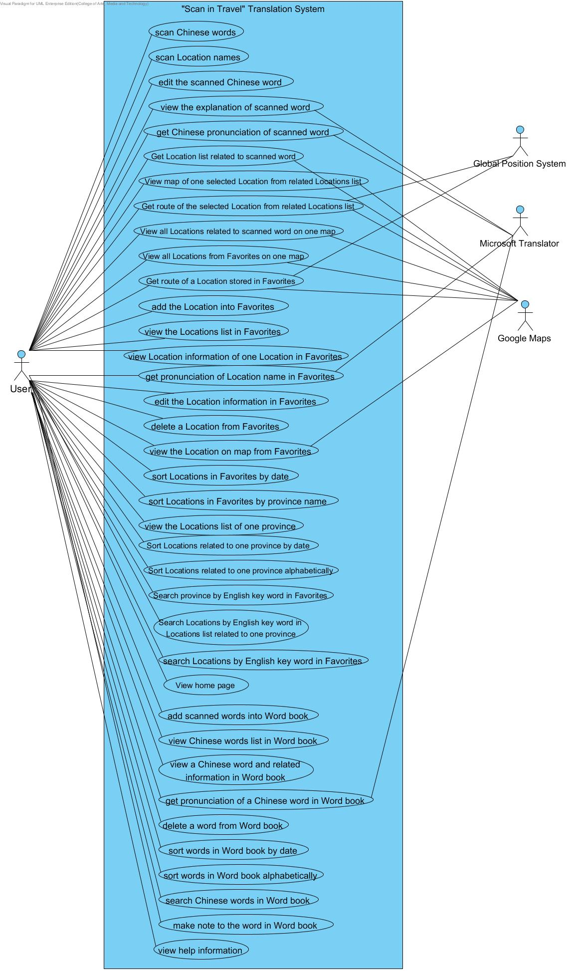
Figure 1: Use Case Diagram of “Scan in Travel” application
4.1.2 Use Case Diagram (Translation System)

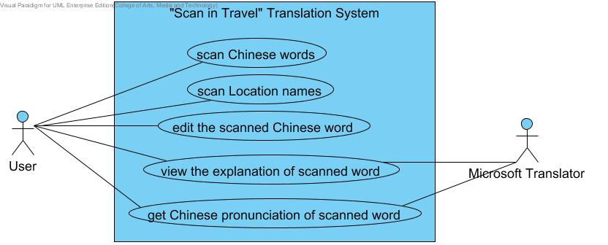

Figure 2: Use Case Diagram of “Scan in Travel” Translation System

4.1.3 Use Case Diagram (Map System)
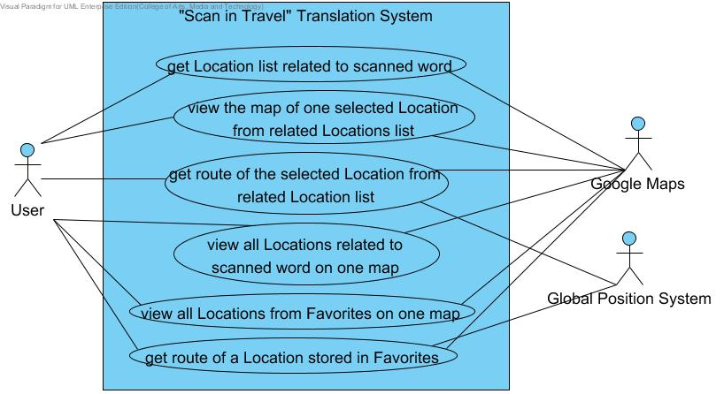

Figure 3: Use Case Diagram of “Scan in Travel” Map System
4.1.4 Use Case Diagram (Favorite System)
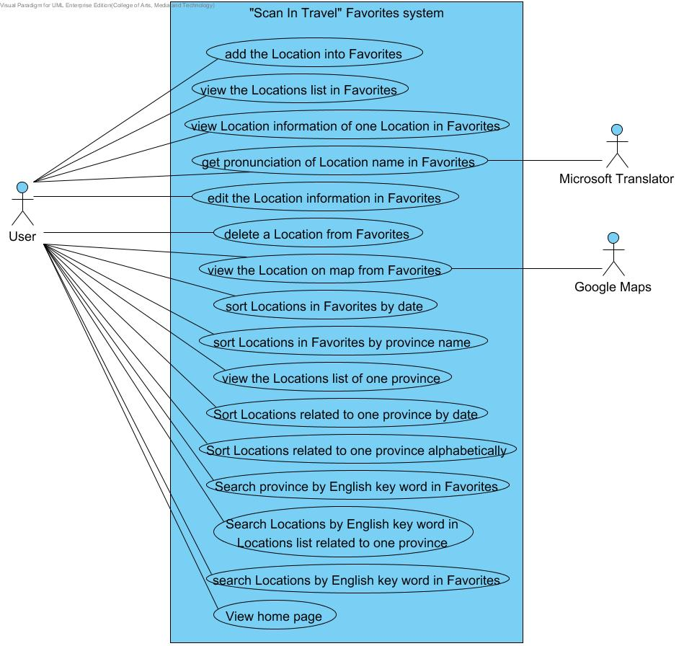

Figure 4: Use Case Diagram of “Scan in Travel” Favorite System

4.1.5 Use Case Diagram (Word book System)

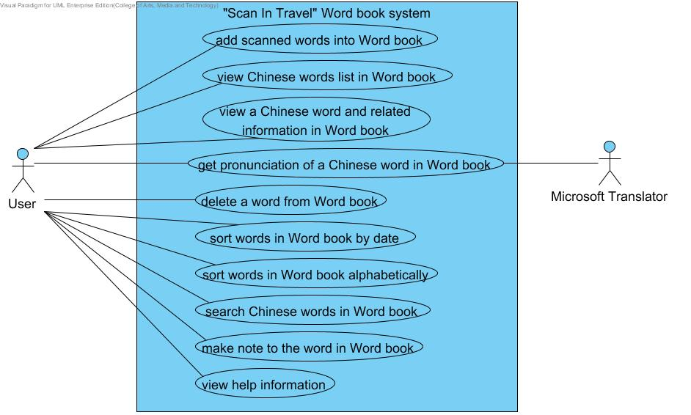

Figure 5: Use Case Diagram of “Scan in Travel” Word book System

4.2 Use Case Description

4.2.1 Feature Name
Translation system

4.2.1.1 Feature Process Flow
Users can translate Chinese words and Location names into English by scanning them with the built-in camera of their mobile phone. After viewing the English translation of a word, users can also select the text-to-speech function to listen to the pronunciation of the Chinese word. Moreover, users can edit the Chinese word(s) that are scanned to get new explanation in English.

4.2.1.2 Use Case(s)

Use Case ID: | UC-01
Use Case Name: | Scan Chinese words and Location names
Created By: | Yirui Wang  Ruijuan Liu | Last Updated By: | Yirui Wang  Ruijuan Liu
Date Created: | 12-03-2014 | Last Revision Date: | 18-07-2014
Actors: | Users
Description: | Users can scan Chinese word(s) and Location name(s) by using built-in camera.
Trigger: | Users choose to scan Chinese word(s) or Location name(s) in China.
Preconditions: | Users start the ‘Scan in Travel’ application.
Post-conditions: | System shall get the searchable text of the scanned Chinese word(s) (or Location name(s)).
Normal Flow: | 1. Users choose to scan Chinese words or Location names in China.  2. System shall invoke the built-in camera of users’ mobile phones.  3. System shall provide user interface for users to scan Chinese words (or Location names) by using built-in camera.  4. System shall provide user interface for users to inform that system can recognize simplified Chinese now.  5. System shall provide instructions “Please focus on one line. You can use finger to change the scanning box.” for users to tell them how to scan Chinese words.  6. Users use the built-in camera of their mobile phone to scan the image of a Chinese words (or Location names).  7. System shall capture the image of the scanned Chinese words (or Location names).  8. System shall recognize the Chinese words (or Location names) and convert the image into searchable text of the scanned Chinese words (or Location names).  *Note: English characters, numbers and punctuations are also recognized successfully.  9. Users view the recognized text of the scanned words(or Location names) that they would like to be translated.
Alternative Flows: | In the step 9 of the Normal Flow, if the Chinese text of scanned words are not the one that users want.  - System shall provide the service for users to change the horizontal size of scan box.  - Users change the horizontal size of scan box to get the accurate recognized Chinese text.  - Use case resumes on the Step 6 of Normal Flow.
Exceptions: | In the step 3 of the Normal Flow, if the system cannot recognize the built-in  camera of users’ mobile phone.  - System shall provide the user interface to display the error message. “Could not initialize camera. Please try restarting device.”  - Users can view the error message: “Could not initialize camera. Please try restarting device.”  3. Use case resumes on step 2 of the Normal Flow.  In the step 6 of Normal Flow, if the scan box is left empty and no Chinese  word is placed within the boundary of the scan box.  1. System shall not get anything about the searchable text of the scanned image.  2. Users shall not view anything about the searchable text of the scanned image.  3. Use case resumes on step 6 of Normal Flow.  In the step 6 of Normal Flow, if the Chinese word that needs to be translated is  not properly focused in the scan box (e.g. The full text is not placed within the  boundary of scan box).  1. System shall display some unrecognizable, broken letters or nothing below the scan box.  2. Users shall view some unrecognizable, broken letters or nothing below the scan box.  3. Use case resumes on step 6 of Normal Flow.  In the step 6 of Normal flow, if the scanned word is not Chinese words, English characters, numbers or punctuation.  1. System shall display some unrecognizable, broken letters or nothing below the scan box.  2. Users shall view some unrecognizable, broken letters or nothing below the scan box.  3. Use case resumes on step 6 of Normal Flow.
Includes: | N/A
Frequency of Use: | Very Frequently
Special Requirements: | 1. Correctness of the recognition.  2. Speed of the recognition.
Assumptions: | 1. Users understand English.  2. Users know how to scan the words.
Notes and Issues: | 1. What is the maximum length of the scanned words?  2. What is the language that the system can recognize?

Activity Diagram (AD-01):
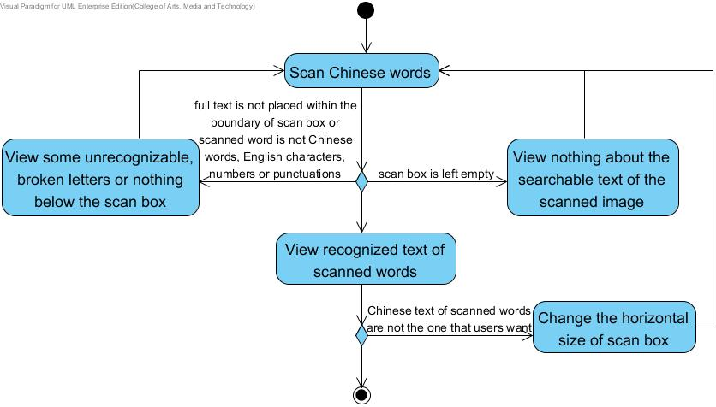

Figure 6: Activity Diagram of “Scan in Travel” AD-01

Use Case ID: | UC-02
Use Case Name: | View the explanation of scanned word
Created By: | Yirui Wang  Ruijuan Liu | Last Updated By: | Yirui Wang  Ruijuan Liu
Date Created: | 12-03-2014 | Last Revision Date: | 18-07-2014
Actors: | Users  Microsoft Translator API
Description: | Users can view the explanation (i.e. meaning, pronunciation) of the scanned word in English.
Trigger: | Users choose to view the explanation of scanned word.
Preconditions: | Users are on the scan page.
Post-conditions: | Users view the explanation (i.e. meaning, pronunciation) of the scanned word in English.
Normal Flow: | 1. Users choose to view the explanation of the scanned word.  2. System shall provide a control (e.g. button) for users to choose to get the explanation of the scanned word.  3. Users choose the “translate” button.  4. System shall receive the request from users to get the explanation of the scanned word.  5. System shall send the text of the scanned Chinese word (or Location name) to Microsoft Translator API.  6. Microsoft Translator API shall translate the text into English.  7. System shall receive the explanation (i.e. meaning, pronunciation) of the scanned word in English from Microsoft Translator API.  8. System shall provide the user interface to display the image of scanned word, the text of the Chinese word and the meaning of the scanned word in English.  9. Users view the meaning of the scanned word in English.
Alternative Flows: | In the step 9 of Normal Flow, if users want to scan Chinese word again.  1. System shall provide a control (e.g. button) for users to choose to return the user interface which users can scan the Chinese words.  2. Users choose the “return” button.  3. System shall receive the request from users to return to the user interface which users can scan the Chinese words.  4. System shall return to the user interface which users can scan the Chinese words and the scanning function will be available.  5. Users can scan other Chinese word and get their explanations.
Exceptions: | In step 5 of Normal Flow, if no internet connection.  - System shall provide the user interface to display the error message. “No internet connection.”  - Users can view the error message. “No internet connection.”  - System shall provide the user interface to display the image of scanned word and the recognized text of the Chinese word only.  - Users can view the user interface to display the image of scanned word and the recognized text of the Chinese word only.  5. Use case ends.  In the step 3 of Normal Flow, if users have not scanned Chinese word or Location name successfully.  1. System shall provide a user interface to show the error message:" Scan failed. Please try again.”  2. Users can view the error message:" Scan failed. Please try again.”  3. Use case resumes on UC-01.  In step 3 of Normal Flow, if the scanned words are not Chinese but some other English characters, numbers or punctuations.  1. Microsoft Translator API cannot translate the word(s) and return the scanned word(s) (i.e. The returned text is same as the recognized text).  2. System shall provide the user interface to display the image of scanned word, the recognized text of scanned word and the translation of recognized text which is same as the recognized text.  3. Users can view the user interface to display the image of scanned word, the recognized text of scanned word and the translation of recognized text which is same as the recognized text.  4. Use case ends.
Includes: | UC-01
Frequency of Use: | Frequently
Special Requirements: | Correctness of the translation.  Speed of receiving the translation from Microsoft Translator API.
Assumptions: | 1. Users understand English.  2. Users know how to operate smart phones.
Notes and Issues: | What is the language that the system can translate?

Activity Diagram (AD-02):

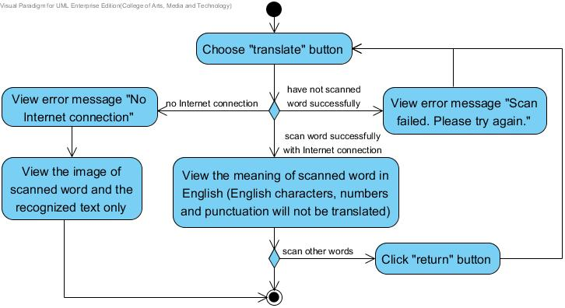

Figure 7: Activity Diagram of “Scan in Travel” AD-02

Use Case ID: | UC-03
Use Case Name: | Get Chinese pronunciation of scanned word
Created By: | Yirui Wang  Ruijuan Liu | Last Updated By: | Yirui Wang  Ruijuan Liu
Date Created: | 12-03-2014 | Last Revision Date: | 18-07-2014
Actors: | Users  Microsoft Translator API
Description: | Users can select Text-to-Speech to get the Chinese pronunciation of the word.
Trigger: | Users choose to get the Chinese pronunciation of scanned word.
Preconditions: | Users have scanned the Chinese word (or Location name) and viewed the explanation of the scanned word successfully. (UC-02)
Post-conditions: | Users get the Chinese pronunciation of the scanned word.
Normal Flow: | 1. System shall provide a control (e.g. Button) on the interface for users to get the proper Chinese pronunciation of the scanned word.  2. Users click “speak” button to get the Chinese pronunciation of the scanned word.  3. System shall send the text of the scanned Chinese word (or Location name) to Microsoft Translator API.  4. Microsoft Translator API shall send the pronunciation of the recognized text to system.  5. System shall receive the pronunciation of the scanned word in Chinese from Microsoft Translator API.  6. System shall pronounce the word to users in Chinese.  7. Users can get the Chinese pronunciation of scanned word.
Alternative Flows: | N/A
Exceptions: | In step 6 of Normal Flow, if the recognized Chinese text includes English character.  1. System shall pronounce the Chinese text to users in Chinese, English character in English.  2. Users can get the pronunciation of the scanned word.  In step 6 of Normal Flow, if the recognized Chinese text includes numbers or punctuations.  1. System shall pronounce the Chinese text to users in Chinese, numbers or punctuations in Chinese as well.  2. Users can get the pronunciation of the scanned word.  In step 3 of Normal Flow, if no internet connection.  1. System shall provide the user interface to display the error message. “No internet connection.”  2. Users can view the error message. “No internet connection.”  3. System cannot provide the Chinese pronunciation to users.  4. Users cannot get the Chinese pronunciation from system.  5. Use case ends.
Includes: | UC-01, UC-02
Frequency of Use: | Very Frequently
Special Requirements: | Correctness of the pronunciation.  Speed of receiving the pronunciation from Microsoft Translator API.
Assumptions: | 1. Users understand English.  2. Users know how to operate smart phones.  3. The smart phone owns built-in speaker.
Notes and Issues: | 1. What language the system can provide the pronunciation?  2. How is the pronunciation of the scanned word?  3. The speed of requesting and receiving the pronunciation of the selected Location name from Microsoft Translator API.  4. The correctness of pronunciation provided by Microsoft Translator API.

Activity Diagram:
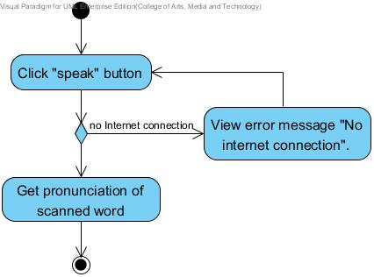

Figure 8: Activity Diagram of “Scan in Travel” AD-03

Use Case ID: | UC-04
Use Case Name: | Edit scanned word
Created By: | Yirui Wang  Ruijuan Liu | Last Updated By: | Yirui Wang  Ruijuan Liu
Date Created: | 13-03-2014 | Last Revision Date: | 03-07-2014
Actors: | Users  Microsoft Translator API
Description: | Users can edit the Chinese word(s) (or Location name(s)) that are scanned to get the new explanation in English.
Trigger: | Users choose to edit the Chinese word(s) of scanned word on display.
Preconditions: | Users have scanned the Chinese word(s)(or Location name(s)) and viewed the explanation of the scanned word successfully.(UC-02)
Post-conditions: | Users get the new explanation of the edited Chinese words.
Normal Flow: | 1. System shall provide a control (e.g. Button) on the interface for users to select to edit the text of the scanned Chinese word(s)(or Location name(s)).  2. Users choose to edit the text of scanned word.  3. System shall provide the user interface for users to edit the text of scanned Chinese word(s) (or Location name(s)).  4. Users edit the scanned Chinese word(s) (or Location name(s)).  5. System shall provide a control (e.g. Button) on the interface for users to indicate that editing is completed.  6. Users choose “Done” button to complete editing and ask to get the new explanation of the edited Chinese word.  7. System shall resume on the UC-02, the step 4 of Normal Flow.  8. Users view the meaning of the edited Chinese word in English.
Alternative Flows: | N/A
Exceptions: | In step of 4 of Normal Flow, if users add Chinese words more than 50 characters.  1. System shall provide the user interface to display the error message:" Text length should not be more than 50.”  2. Users can view the error message:" Text length should not be more than 50.”  3. Users can not add more characters.  4. Use case resumes on the step 3 of Normal Flow.  In step 6 of Normal Flow, if users delete all the words.  1. System shall provide the user interface to display error message: “Text length should not be empty.”  2. Users can view the error message: “Text length should not be empty.”  3. Users can click “Done” button.  4. System shall return to the user interface for scanning Chinese words (or Location names). (UC-01)  5. Users can view the user interface for scanning Chinese words (or Location names).  6. Use case ends.  In step 6 of Normal Flow, if no internet connection.  1. System shall provide the user interface to display the error message. “No internet connection.”  2. Users can view the error message. “No internet connection.”  3. System shall provide the user interface to display the image of scanned word and the text of the edited Chinese word only.  4. Users can view the image of scanned word and the text of the edited Chinese word only.  5. Use case ends.
Includes: | UC-01, UC-02
Frequency of Use: | Frequently
Special Requirements: | N/A
Assumptions: | 1. Users understand English.  2. Users know how to operate smart phones.  3. Users know how to edit the word.  4. Users know how to use the keyboard of their phone.
Notes and Issues: | N/A

Activity Diagram:

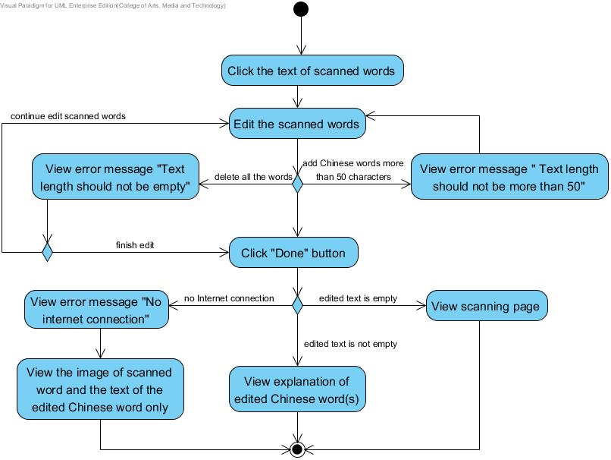

Figure 9: Activity Diagram of “Scan in Travel” AD-04

4.2.2 Feature Name
Map system

4.2.2.1 Feature Process Flow
Users can scan a Location name and find where it is located on a map. The system will guide users to get to the Location by providing a route on a map. Besides, users can keep their own map of every Location in their Favorites (see below for details). The system lets users see every saved Location on a map, and check the details of each Location.

4.2.2.2 Use Case(s)

Use Case ID: | UC-05
Use Case Name: | Get Location list related to scanned word
Created By: | Yirui Wang  Ruijuan Liu | Last Updated By: | Yirui Wang  Ruijuan Liu
Date Created: | 13-03-2014 | Last Revision Date: | 03-07-2014
Actors: | Users  Google Maps API
Description: | Users can get the Locations list including Locations related to scanned word with the Location name both in Chinese and English.
Trigger: | Users choose to get the map of scanned word.
Preconditions: | Users have scanned the Chinese word(s)(or Location name(s)) and viewed the explanation of the scanned word successfully.(UC-02)
Post-conditions: | Users get the list of Locations related to scanned Chinese words.
Normal Flow: | 1. System shall provide a control (e.g. Button) on the interface for users to select to get the map of the scanned Location name(s)).  2. Users choose to get the map of scanned word.  3. System shall receive the request from users to get the map of the scanned word.  4. System shall send the text of the scanned Chinese word (or Location name) to Google Maps API.  5. Google Maps API shall search the Locations related to scanned word.  6. Google Maps API shall send the related Location list of scanned word to system.  7. System shall receive the related Location list (including Chinese Location name, English Location name) of the scanned word from Google Maps API.  8. System shall provide the user interface for users to show the list of Locations related to scanned word with the Location name both in Chinese and English.  9. Users view the Locations list including Locations related to scanned word with the Location name both in Chinese and English.
Alternative Flows: | N/A
Exceptions: | In step of 5 of Normal Flow, if the scanned word is not a Location name, Google Map cannot find any location related to the scanned word.  1. System shall provide the user interface to display the error message:" No location related to the scanned word or no internet connection.”  2. Users can view the error message:" No location related to the scanned word or no internet connection.”  3. Use case ends.  In step of 5 of Normal Flow, if the scanned word is a location name but not in China, system is not supported to show the Locations out of China.  1. System shall provide the user interface to display the error message:" No location related to the scanned word or no internet connection.”  2. Users can view the error message:" No location related to the scanned word or no internet connection.”  3. Use case ends.  In step 5 of Normal Flow, if there is no internet connection.  - System shall display the error message:" No location related to the scanned word or no internet connection.”  2. Users can view the error message:" No location related to the scanned word or no internet connection.”  3. Use case ends.
Includes: | UC-01, UC-02
Frequency of Use: | Frequently
Special Requirements: | Correctness and comprehensiveness of the Locations list.
Assumptions: | 1. Users understand English.  2. Users know how to operate smart phones.  3. Users know the basic information about the Location.
Notes and Issues: | N/A

Activity Diagram:
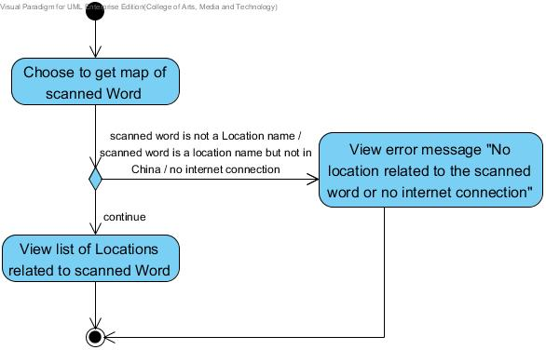

Figure 10: Activity Diagram of “Scan in Travel” AD-05

Use Case ID: | UC-06
Use Case Name: | View the map of one selected Location from related Locations list
Created By: | Yirui Wang  Ruijuan Liu | Last Updated By: | Yirui Wang  Ruijuan Liu
Date Created: | 13-03-2014 | Last Revision Date: | 03-07-2014
Actors: | Users  Google Maps API
Description: | Users can select one Location from Locations list which is related to the scanned word(s) to view its location on map.
Trigger: | Users choose to view the map of one Location from related Locations list.
Preconditions: | Users have viewed the Locations list including Locations related to scanned word with the Location name successfully.(UC-05)
Post-conditions: | Users get the map of one Location that they selected from related Locations list.
Normal Flow: | 1. System shall provide a control for users to select one Location from related Locations list to get the map of this Location.  2. Users choose one Location from related Locations list to get the map.  3. System shall receive the request from users to get the map of the Location.  4. System shall send the geometry information ( latitude and longitude) of the selected Location to Google Maps API.  5. Google Maps API shall search the map of the selected Location.  6. Google Maps API shall send the map of selected Location to system.  7. System shall receive the map of the selected Location from Google Maps API.  8. System shall provide the user interface for users to show the map of selected Location with marker.  9. Users view the map of selected Location with marker and they can view the Chinese Location name and English Location name by click the marker.
Alternative Flows: | In the step 9 of the Normal Flow, if users want to return to the previous related Locations list.  1. System shall provide a control (e.g. button) to users to return to the previous related Locations list.  2. Users choose “Return” button.  3. Use case resumes on the step 1 of Normal Flow.
Exceptions: | In step 4 of Normal Flow, if no internet connection.  1. System shall provide the user interface to display the error message:" No internet connection”.  2. Users can view the error message:" No internet connection”.  3. System shall provide the user interface to display an empty map.  4. Users view an empty map.  5. Use case ends.
Includes: | UC-01, UC-02, UC-05
Frequency of Use: | Frequently
Special Requirements: | 1. Correctness and expatiation of the map.  2. Correctness and comprehensiveness of the Location catalogue.
Assumptions: | 1. Users understand English.  2. Users knows how to operate smart phones.  3. Users know the basic information about the Location.  4. Users know how to use the electronic map.
Notes and Issues: | 1. What is the proportion of the map?  2. How could the system figure out where users want to look in detail?  3. How could the system figure out how much general users want?

Activity Diagram:
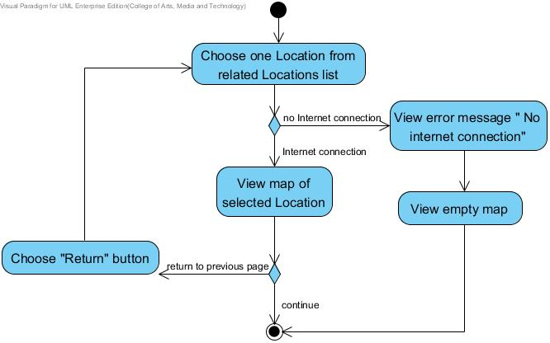

Figure 11: Activity Diagram of “Scan in Travel” AD-06

Use Case ID: | UC-07
Use Case Name: | Get route of the selected Location from related Locations list
Created By: | Yirui Wang  Ruijuan Liu | Last Updated By: | Yirui Wang  Ruijuan Liu
Date Created: | 14-03-2014 | Last Revision Date: | 03-07-2014
Actors: | Users  Google Maps API  Global Position System
Description: | Users can view the map that shows the route from the current position to the selected Location from Locations list which is related to the scanned word(s).
Trigger: | Users choose to show the route of selected Location from related Locations list.
Preconditions: | Users viewed the map of one Location from related Locations list before.(UC-06)
Post-conditions: | Users can get the map that shows the route from the current position to the selected Location from Locations list.
Normal Flow: | 1. Users choose to show the route from current position to selected Location.  2. System shall provide a control (e.g. button) for users to choose get route from current position to selected Location.  3. Users choose “Get route” button.  4. System shall receive the request from users to get the route from current position to selected Location.  5. System shall send the geometry information (latitude and longitude) of the selected Location to Google Maps API.  6. System shall use Global Position System to get the current position of users.  7. System shall send the current position geometry information (latitude and longitude) of users to the Google Maps API.  8. Google Maps API shall send the related information to the system.  9. System shall receive the route information from the current position to the Location selected by users from related Locations list.  10. System shall provide the user interface to display the markers of the users’ current position and the selected Location on the map.  11. System shall provide the user interface to display the route from the current position to the Location selected by users from related Locations list on the map.  12. Users can view the map that shows the route from the current position to the Location.
Alternative Flows: | In the step 6 of the Normal Flow, if users did not open the GPS service on their mobile phone.  - System shall provide the user interface to display the error message. “Please open your GPS service to allow Google Map to get your location.”  - Users can view the error message. “Please open your GPS service to allow Google Map to get your location.”  - Use case ends.  In the step 12 of the Normal Flow, if users want to return to the previous related Locations list.  1. System shall provide a control (e.g. button) to users to return to the previous related Locations list.  2. Users choose “Return” button.  3. Use case resumes on the UC-05.
Exceptions: | In step 5 of Normal Flow, if no internet connection.  - System shall provide the user interface to display the error message. “No internet connection.”  - Users can view the error message. “No internet connection.”  - Use case ends.  In the step 8 of the Normal Flow, if users’ current position is not in China and it is far from China.  1. Google Maps API cannot get the route from current position to selected Location.  2. System shall show the error message:" No route”.  3. Users can view the error message:" No route”.  4. Use case ends.
Includes: | UC-01, UC-02, UC-05, UC-06
Frequency of Use: | Frequently
Special Requirements: | 1. Correctness and expatiation of the map.  2. Correctness and comprehensiveness of the route.
Assumptions: | 1. Users understand English.  2. Uses know how to operate smart phones.  3. Users know how to use the electronic map.
Notes and Issues: | 1. What is the proportion of the map?  2. How could the system figure out where user wants to look in detail?  3. How could the system figure out how much general users want?

Activity Diagram:
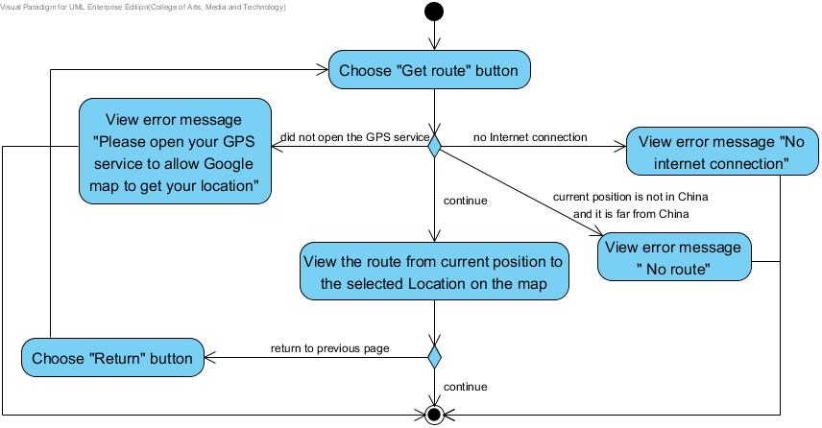

Figure 12: Activity Diagram of “Scan in Travel” AD-07
Use Case ID: | UC-08
Use Case Name: | View all Locations related to scanned word(s) on one map
Created By: | Yirui Wang  Ruijuan Liu | Last Updated By: | Yirui Wang  Ruijuan Liu
Date Created: | 14-03-2014 | Last Revision Date: | 03-07-2014
Actors: | Users  Google Maps API
Description: | Users can view all Locations related to scanned word(s) on one map.
Trigger: | Users choose to view all Locations related to scanned word(s) on one map.
Preconditions: | 1. Users have scanned the Chinese word(s)(or Location name(s)) and viewed the explanation of the scanned word successfully.(UC-02)
Post-conditions: | Users can view all Locations related to scanned word(s) on one map.
Normal Flow: | - System shall provide a thumbnail map to help users know the general position of related Locations on the map.  - Users choose to view all Locations related to scanned word(s) on one map.  - System shall provide the user interface to display all the related Locations on one map.  - Users can view all the related Locations with markers on one map.
Alternative Flows: | In the step 4 of the Normal Flow, if users want to view the name of each Location.  1. System shall provide a marker for each Location.  2. Users can click the marker.  3. System shall provide an information window for users to show the Chinese Location name and English Location name of the clicked Location.  4. Users can view the Chinese Location name and English Location name of the Location by click the marker.  In the step 4 of the Normal Flow, if users want to return to the previous related Locations list.  1. System shall provide a control (e.g. button) to users to return to the previous related Locations list.  2. Users choose “Return” button.  3. Use case resumes on the step 1 of the Normal Flow.
Exceptions: | In step 1 of Normal Flow, if no internet connection.  1. System shall provide the user interface to display the error message. “No internet connection.”  2. Users can view the user interface to display the error message. “No internet connection.”  3. Use case ends.
Includes: | UC-01, UC-02, UC-05
Frequency of Use: | Frequently
Special Requirements: | 1. Correctness and expatiation of the map.  2. Correctness and comprehensiveness of Locations.
Assumptions: | 1. Users understand English.  2. Users knows how to operate smart phones.  3. Users know how to use the electronic map.  4. Users know the basic information about the Locations.
Notes and Issues: | 1. What is the proportion of the map?  2. How could the system figures out where user wants to look in detail?  3. How could the system figures out how much general users want?

Activity Diagram:
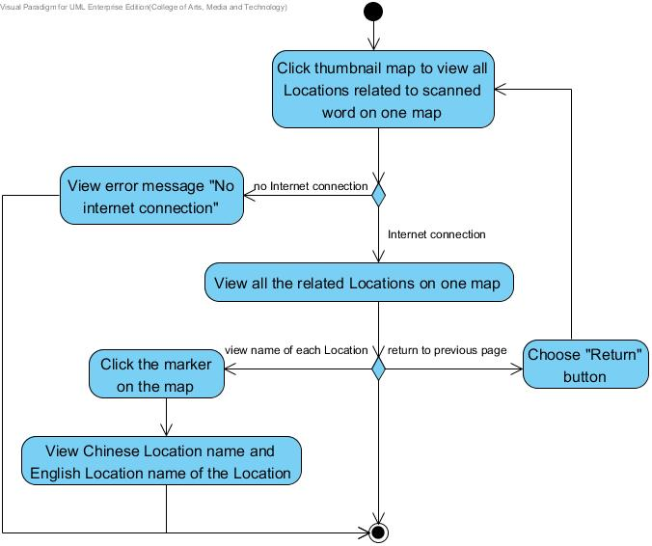

Figure 13: Activity Diagram of “Scan in Travel” AD-08

Use Case ID: | UC-09
Use Case Name: | View all Locations from their own Favorites on one map
Created By: | Yirui Wang  Ruijuan Liu | Last Updated By: | Yirui Wang  Ruijuan Liu
Date Created: | 16-03-2014 | Last Revision Date: | 03-07-2014
Actors: | Users  Google Maps API
Description: | Users can view all Locations from their own Favorites on one map.
Trigger: | Users choose to view all Locations in their own Favorites.
Preconditions: | Users have saved Location information into their Favorites before.
Post-conditions: | Users can view all Locations from their Favorites on the map.
Normal Flow: | 1. System shall retrieve all the Location data in their own Favorites from database.  2. System shall send all the Locations geometry information (latitude and longitude) to the Google Maps API.  3. Google Maps API shall search the related information of all Locations from Favorites.  4. Google Maps API shall send the map to system.  5. System shall provide a thumbnail map to help users know the general position of all Locations in their Favorites.  6. Users choose to view all Locations from their Favorites on the map.  7. System shall send all the Locations geometry information (latitude and longitude) to the Google Maps API.  8. Google Maps API shall search the related information of all Locations from Favorites.  9. Google Maps API shall send the map to system.  10. System shall provide the user interface for users to show the map of all Locations in the Favorites with markers.  11. Users can view all Locations from their own Favorites on the map.
Alternative Flows: | In the step 11 of the Normal Flow, if users want to view the name of each Location.  1. System shall provide a marker for each Location.  2. Users can click the marker.  3. System shall provide an information window for users to show the Chinese Location name and English Location name of the clicked Location.  4. Users can view the Chinese Location name and English Location name of the Location by click the marker.  In the step 11 of the Normal Flow, if users want to return to the Favorites list.  1. System shall provide a control (e.g. button) to users to return to the previous related Locations list.  2. Users choose “Return” button.  3. Use case resumes on the step 1 of the Normal Flow.
Exceptions: | In step 3 of Normal Flow, if no internet connection.  1. System shall provide the user interface to display the error message. “No internet connection.”  2. Users can view the error message. “No internet connection.”  3. Use case ends.
Includes: | UC-11, UC-12
Frequency of Use: | Frequently
Special Requirements: | 1. Correctness and expatiation of the map.  2. Correctness and comprehensiveness of all Locations.
Assumptions: | 1. Users know how to use the electronic map.  2. Users have saved Location(s) into their own Favorites before.
Notes and Issues: | 1. What is the proportion of the map?  2. How could the system figures out where user wants to look in detail?  3. How could the system figures out how much general users want?

Activity Diagram:
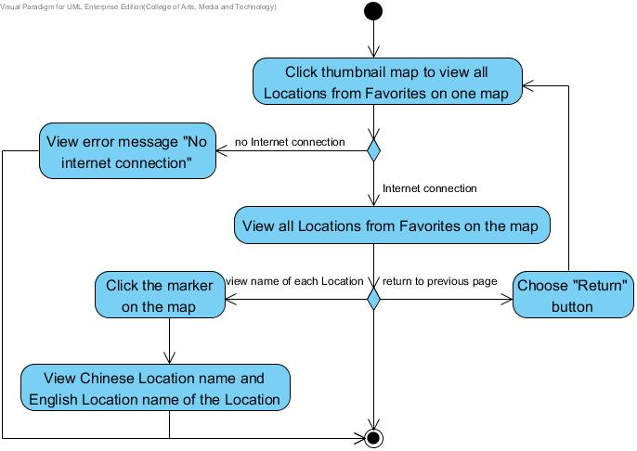

Figure 14: Activity Diagram of “Scan in Travel” AD-09

Use Case ID: | UC-10
Use Case Name: | Get route of a Location stored in Favorites
Created By: | Yirui Wang  Ruijuan Liu | Last Updated By: | Yirui Wang  Ruijuan Liu
Date Created: | 12-04-2014 | Last Revision Date: | 03-07-2014
Actors: | Users  Google Maps API  Global Position System
Description: | Users can view the map that shows the route from the current position to a Location selected from their own Favorites.
Trigger: | Users choose to view get the route of a Location.
Preconditions: | 1. Users saved Location information into their Favorites before.  2. Users have viewed the selected Location from Favorites list on the map.
Post-conditions: | Users can get the map that shows the route from the current position to a Location stored in Favorites.
Normal Flow: | 1. Users choose to get the route from the current position to a Location selected from Favorites list.  2. System shall provide a control (e.g. button) for users to choose get route from current position to selected Location.  3. Users shall choose” Get route” button to get route.  4. System shall send the geometry information (latitude and longitude) of the selected Location to Google Maps API.  5. System shall use Global Position System to get the current position of users.  6. System shall send the current position geometry information (latitude and longitude) of users to the Google Maps API.  7. Google Maps API shall send the related information to the system.  8. System shall receive the route information from the current position to the Location selected by users in their own Favorites.  9. System shall provide the user interface to display the markers of the users’ current position and the selected Location.  10. System shall provide the user interface to display the route from the current position to the Location selected by users in their own Favorites on map.  11. Users can view the map that shows the route from the current position to the selected Location.
Alternative Flows: | In the step 5 of the Normal Flow, if users did not open the GPS service on their mobile phone.  1. System shall provide the user interface to display the error message. “Please open your GPS service to allow Google Map to get your location.”  2. Users can view the error message. “Please open your GPS service to allow Google Map to get your location.”  3. Use case ends.  In the step 7 of the Normal Flow, if users want to return to the Location information page.  1. System shall provide a control (e.g. button) to users to return to the previous Location information page.  2. Users choose “Return” button.  3. Use case ends.
Exceptions: | In step 4 of Normal Flow, if no internet connection.  - System shall provide the user interface to display the error message. “No internet connection.”  - Users can view the error message. “No internet connection.”  In the step 7 of the Normal Flow, if users’ current position is not in China and it is far from China.  1. Google Maps API cannot get the route from current position to selected Location.  2. System shall show the error message:" No route”.  3. Users can view the error message:" No route”.  4. Use case ends.
Includes: | UC-11, UC-12, UC-13, UC-17
Frequency of Use: | Frequently
Special Requirements: | 1. Correctness and expatiation of the map.  2. Correctness and comprehensiveness of the route.
Assumptions: | 1. Users understand English.  2. Uses know how to operate smart phones.  3. Users know how to use the electronic map.  4. Users saved Location(s) into their own Favorites before.
Notes and Issues: | 1. What is the proportion of the map?  2. How could the system figure out where user wants to look in detail?  3. How could the system figure out how much general users want?

Activity Diagram:
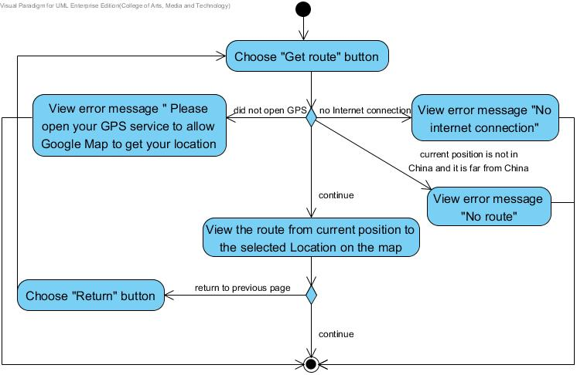

Figure 15: Activity Diagram of “Scan in Travel” AD-10

4.2.3 Feature Name
Favorites system

4.2.3.1 Feature Process Flow
After users scan a Location name, they can save the Location with its name both in Chinese and English, pictures, geometry information (i.e. latitude and longitude), and descriptions into their Favorites. Users can add the picture of the Location from their own gallery and write down their own description for it. Moreover, users can select to sort Locations in their Favorites alphabetically, sort Locations by province and sort Locations by date also. Meanwhile, users can search Locations by English keyword.

4.2.3.2 Use Case(s)

Use Case ID: | UC-11
Use Case Name: | Add the Location into Favorites
Created By: | Yirui Wang  Ruijuan Liu | Last Updated By: | Yirui Wang  Ruijuan Liu
Date Created: | 12-04-2014 | Last Revision Date: | 03-07-2014
Actors: | Users
Description: | Users can add the selected Location from Locations list which is related to the scanned word with its Chinese name, English name, pictures, geometry information (i.e. latitude and longitude), and Location descriptions into their Favorites.
Trigger: | Users select the service to add the selected Location from Location list which is related to the scanned word into their own Favorites.
Preconditions: | 1. The service to add the scanned Location into Favorites is available.  2. The system is on running status, and is on the interface which displays the selected Location from related Locations list on the map.
Post conditions: | System shall add the selected Location with its Chinese name, English name. pictures, geometry information, and description into database.
Normal Flow: | - Users choose to add the selected Location into their own Favorites.  - System shall provide a control (e.g. button) for users to add the selected Location into Favorites.  - Users can click “Add to Favorites” button.  - System shall provide the user interface to receive the data from users to add the selected Location. The data includes Location English name, pictures and description information.  - System shall provide the Chinese name, English name and geometry information of the selected Location for users.  - Users can add pictures and description information about the selected Location, and can also edit the English name.  - System shall provide the user interface to display the updated information of Location.  - Users can view the updated information of Location.  - Users select to “OK” to add this Location.  - System shall add the selected Location with its Chinese name, English name, pictures, geometry information, and description into database.  - System shall provide the user interface to display the successful message “Location added successfully!”  - System shall provide two controls (e.g. button) for users to view Favorites list page or return to Add Location page.  - Users click “View Favorites” button.  14. System shall provide the user interface to display the Favorites page with new Location.  15. Users can view the Favorite page with new Location.
Alternative Flows: | In the step 4 of Normal Flow, users can select to cancel the addition of the scanned Location into the Favorites.  1. System shall provide a control (e.g. button) for users to cancel the service of add the selected Location.  2. Users select “Cancel” button to cancel the addition of the scanned Location into the Favorites.  3. System shall cancel the service of add the selected Location.  4. Use case ends. (Use case resumes on the UC-05, system shall return to the related Location list).  In the step 8 of Normal Flow, if users want to view the picture that they add.  1. System shall provide the user interface to display thumbnail pictures that they select to add for the selected Location.  2. Users click one picture to view its detail.  3. System shall provide the user interface to display the detailed picture of the selected one.  4. Users can view the detailed picture.  5. System shall provide a control (e.g. button) for users to cancel the service of viewing detailed picture.  6. Users select “Cancel” button.  7. System shall return to previous editing page.  8. Use case resumes on step 6 of Normal Flow.  In the step 8 of Normal Flow, if users want to delete the picture that they add.  1. System shall provide the user interface to display thumbnail pictures that they select to add for the selected Location.  2. Users click one picture to view its detail.  3. System shall provide the user interface to display the detailed picture of the selected one.  4. System shall provide a control (e.g. button) for users to delete the current picture.  5. Users select “delete” button.  6. System shall delete the current picture.  7. System shall return to the previous adding page.  8. Use case resumes on step 7 of Normal Flow.  In the step 15 of Normal Flow, if users want to return to the Add Location page.  - Users click “OK” button.  - System shall return to the previous adding page.  - Users can view the adding page.  - Use case ends.
Exceptions: | In the step 6 of Normal Flow, the length of the English name that users provide is more than 120 characters.  1. System shall provide the user interface to display the error message. “Location’s English name should not be more than 120 characters.”  2. Users can view the error message. “Location’s English name should not be more than 120 characters.”  3. Users can not add more characters in edit area.  4. Use case resumes on step 6 of Normal Flow.  In the step 6 of Normal Flow, the length of the description information that users provide is more than 1500 characters.  1. System shall provide the user interface to display the error message. “Description should not be more than 1500 characters.”  2. Users can view the error message. “Description should not be more than 1500 characters.”  3. Users can not add more characters in description area.  4. Use case resumes on step 6 of Normal Flow.  In the step 6 of Normal Flow, the amount of pictures that users provide is more than 200.  1. System shall provide the user interface to display the error message. “The amount of pictures should not be more than 200.”  2. Users can view the error message. “The amount of pictures should not be more than 200.”  3. Users can not add more pictures.  4. Use case resumes on step 6 of Normal Flow.  In the step 9 of Normal Flow, if the Location already existed in the Favorites.  1. System shall provide the user interface to display the error message: “Location exists already”.  2. Users can view the error message: “Location exists already”.  3. Users can not add the existed Location again.  4. Use case ends.
Includes: | UC-05, UC-06
Frequency of Use: | Frequently
Special Requirements: | 1. The data of the selected Location that are stored in database should be same as the data that users provide.  2. The data of the selected Location that users provide must satisfy the proper formats.
Assumptions: | 1. Users understand English language.  2. Users know how to operate smart phones.  3. Users know how to upload pictures.  4. Users know how to key the text on smart phones.
Notes and Issues: | - The speed of storing the added Location in the database.  - The completeness of data of the scanned Location which are added to database.

Activity Diagram:
Primary activity diagram of UC-11

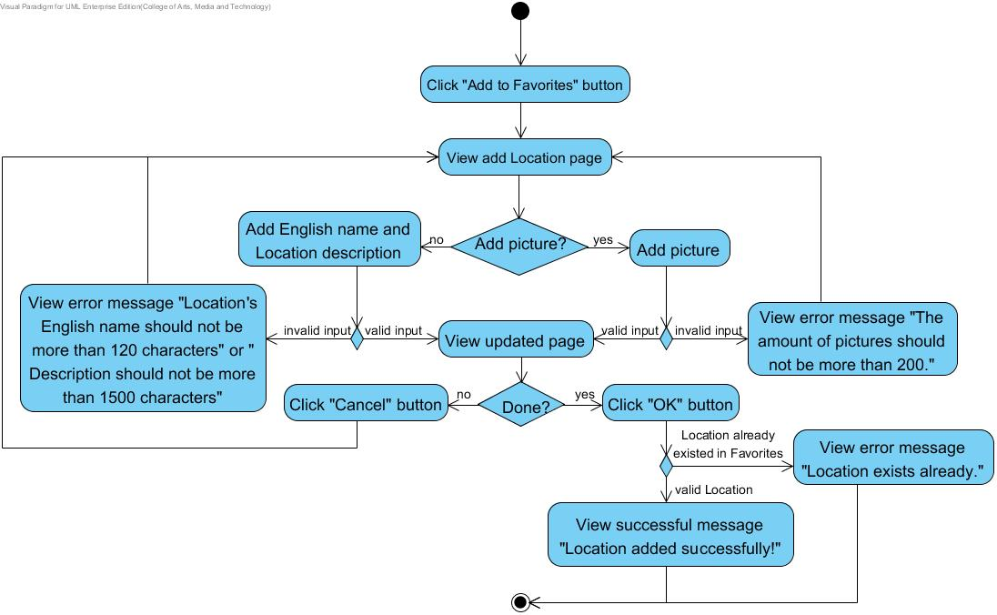

Figure 16: Activity Diagram of “Scan in Travel” AD-11-1

Sub activity diagram (Add picture) of UC-11
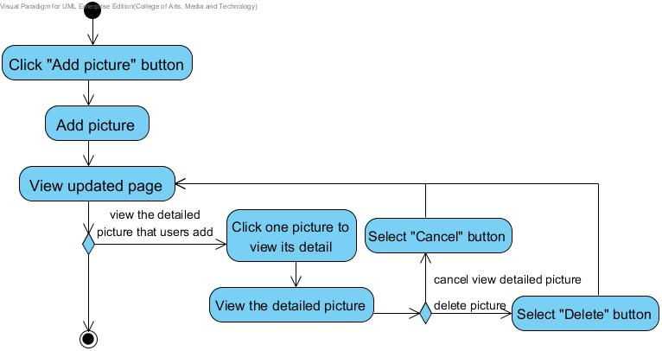

Figure 17: Activity Diagram of “Scan in Travel” AD-11-2

Use Case ID: | UC-12
Use Case Name: | View the Locations list in Favorites
Created By: | Yirui Wang  Ruijuan Liu | Last Updated By: | Yirui Wang  Ruijuan Liu
Date Created: | 12-04-2014 | Last Revision Date: | 03-07-2014
Actors: | Users
Description: | Users can view a list of Locations with their Chinese name, English name and added date in their own Favorites.
Trigger: | Users choose to view the Location list in their Favorites.
Preconditions: | The service to view the Locations list in Favorites is available.
Post conditions: | System shall provide the user interface to display a list of Locations with their Chinese name, English name and added date in their own Favorites.
Normal Flow: | 1. Users choose to view the Locations list in their Favorites.  2. System shall provide a control (e.g. button) for users to view the Locations list in their Favorites.  3. Users click “Favorites” button.  4. System shall retrieve all the Locations data in their own Favorites from database.  5. System shall provide user interface to display a list of Locations from Favorites with their Chinese name, English name and added date.  6. Users can view a list of Locations with their Chinese name, English name and added date in their own Favorites.
Alternative Flows: | N/A
Exceptions: | In the step 3 of Normal Flow, there is no Location found in database.  1. System shall provide the user interface to display the error message: “No Locations in Favorites”.  2. Users can view the error message: “No Locations in Favorites”.  3. Use case ends.
Includes: | N/A
Frequency of Use: | Frequently
Special Requirements: | The Location whose information are viewed from database must be same as the Location that user added before.
Assumptions: | 1. Users understand English language.  2. Users know how to operate smart phones.
Notes and Issues: | 1. The speed of retrieving Locations list from database.  2. The correctness and completeness of the data of the Locations list.

Activity Diagram:
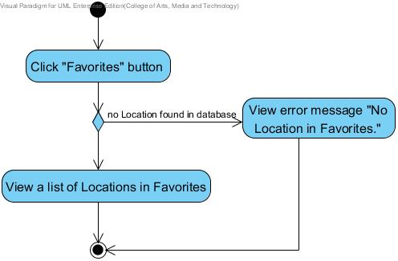

Figure 18: Activity Diagram of “Scan in Travel” AD-12

Use Case ID: | UC-13
Use Case Name: | View the Location information of one Location in Favorites
Created By: | Yirui Wang  Ruijuan Liu | Last Updated By: | Yirui Wang  Ruijuan Liu
Date Created: | 13-04-2014 | Last Revision Date: | 03-07-2014
Actors: | Users
Description: | Users can select one Location from Favorites to view its information with Chinese name, English name, pictures, geometry information (i.e. latitude and longitude), and Location description in their Favorites.
Trigger: | Users choose to view the Location information of one Location in their Favorites.
Preconditions: | - The service to view the information of a Location in Favorites is available.  - Users have added Location into Favorites successfully.  - Users are on the Favorites page.
Post conditions: | System shall provide the user interface to display the Location information of selected Location with Chinese name, English name, pictures, geometry information and description in their favorites.
Normal Flow: | 1. Users select one Location from Favorites list to view the Location information of that Location.  2. System shall receive the request from users to get the Location information of selected Location.  3. System shall retrieve the Location information of selected Location from database.  4. System shall provide the user interface for users to view the Location information with Chinese name, English name, pictures, geometry information and description of selected Location in their Favorite.  5. Users can view the Location information of selected Location with Chinese name, English name, picture, geometry information and description in their favorites.
Alternative Flows: | In the step 5 of the Normal Flow, if users want to return to the Favorites list page.  1. System shall provide a control (e.g. button) to users to return to the previous Locations list in Favorites.  2. Users choose “Return” button.  3. Use case ends. (Use case resumes on the UC-12, system shall return to the Locations list in Favorites).
Exceptions: | N/A
Includes: | UC-11, UC-12
Frequency of Use: | Frequently
Special Requirements: | The Location whose information are viewed from database must be same as the Location that user select.
Assumptions: | 1. Users understand English language.  2. Users know how to operate smart phones.
Notes and Issues: | 1. The speed of retrieving a selected Location from database.  2. The correctness and completeness of the data of the selected Location.

Activity Diagram:

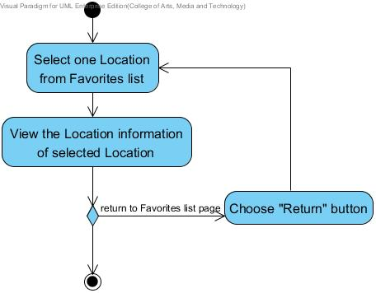

Figure 19: Activity Diagram of “Scan in Travel” AD-13

Use Case ID: | UC-14
Use Case Name: | Get the pronunciation of Location Chinese name in Favorites
Created By: | Yirui Wang  Ruijuan Liu | Last Updated By: | Yirui Wang  Ruijuan Liu
Date Created: | 13-04-2014 | Last Revision Date: | 03-07-2014
Actors: | Users  Microsoft Translator API
Description: | Users can select Text-To-Speech to get the pronunciation of the Location name in Chinese from their own Favorites.
Trigger: | Users select the service to get the pronunciation of Location name in their Favorites.
Preconditions: | - Users choose to get the pronunciation of Location Chinese name in Favorites is available.  - Users have added Location into Favorites successfully.  - Users have viewed Location information of one Location successfully.  4. The connection between system and Microsoft Translator API is available.
Post conditions: | Users can get the proper pronunciation of the selected Location name.
Normal Flow: | 1. Users choose to get the pronunciation of Location Chinese name in their Favorites.  2. System shall provide a control (e.g. button) for users to request for the proper pronunciation of the Location Chinese name in their Favorites.  3. Users click “Speak” button.  4. System shall send the Chinese name of the selected Location to Microsoft Translator API.  5. Microsoft Translator API shall retrieve the pronunciation data of the Chinese name.  6. Microsoft Translator API shall send the pronunciation data to system.  7. System shall receive the pronunciation of the selected Location name in Chinese.  8. System shall pronounce the Location name to users in Chinese.  9. Users get the proper pronunciation of the selected Location name.
Alternative Flows: | N/A
Exceptions: | In the step 4 of Normal Flow, there is no internet connection.  1. System shall provide the user interface to display the error message. “No internet connection.”  2. Users can view the error message. “No internet connection.”  3. Use case ends.
Includes: | UC-12, UC-13
Frequency of Use: | Frequently
Special Requirements: | Correctness of the pronunciation.
Assumptions: | 1. Users understand English language.  2. Users know how to operate smart phones.  3. The smart phone owns built-in speaker.
Notes and Issues: | 1. The speed of requesting and receiving the pronunciation of the selected Location name from Microsoft Translator API.  2. The correctness of pronunciation provided by Microsoft Translator API.  3. What language the system can provide the pronunciation?  4. How is the pronunciation of the scanned word?

Activity Diagram:
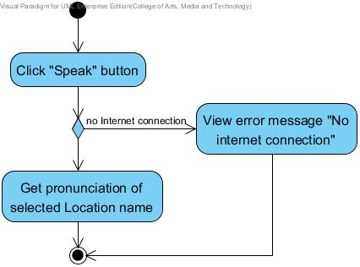

Figure 20: Activity Diagram of “Scan in Travel” AD-14

Use Case ID: | UC-15
Use Case Name: | Edit the Location information in Favorites
Created By: | Yirui Wang  Ruijuan Liu | Last Updated By: | Yirui Wang  Ruijuan Liu
Date Created: | 13-04-2014 | Last Revision Date: | 03-07-2014
Actors: | Users
Description: | Users can edit the Location information with English name, pictures and Location description in their own Favorites.
Trigger: | Users choose to edit the Location information in their own Favorites.
Preconditions: | - Users have added the Location into Favorites successfully.  - Users have viewed the Location information of selected Location in Favorites successfully.
Post conditions: | System shall edit the Location information of selected Location with its English name, pictures and description.
Normal Flow: | 1. Users choose to edit the Location information of selected Location in their own Favorites.  2. System shall provide a control (e.g. button) for users to edit the Location information of selected Location in Favorites.  3. Users can click “Edit” button.  4. System shall provide the user interface for users to edit Location information with English name, pictures and Location description.  5. System shall retrieve the selected Location data from database.  6. System shall provide the Chinese name, English name, pictures and geometry information of the selected Location for users. And allow users to edit English name, pictures and Location description.  7. Users edit the English name, pictures and description information about the selected Location.  8. Users select to “OK” to update the Location information of selected Location.  9. System shall update the Location information of selected Location into database.  10. Users can view the edited Location information page.
Alternative Flows: | In the step 4 of Normal Flow, users can select to cancel the edit service.  1. System shall provide a control (e.g. button) for users to cancel the service of edit the Location information.  2. Users select “Cancel” button to cancel the edition service.  3. System shall cancel the service of editing the Location information.  4. Use case ends. (Use case resumes on the UC-13, system shall return to the Location information of selected Location).  In the step 7 of Normal Flow, if users want to view the picture that they edit.  1. System shall provide the user interface to display thumbnail pictures are stored of the selected Location.  2. Users click one picture to view its detail.  3. System shall provide the user interface to display the detailed picture of the selected one.  4. Users can view the detailed picture of selected one.  5. System shall provide a control (e.g. button) for users to cancel the service of viewing detailed picture.  6. Users select “Cancel” button.  7. System shall return to previous editing page.  8. Use case resumes on step 7 of Normal Flow.  In the step 7 of Normal Flow, if users want to delete the picture that they edit.  1. System shall provide the user interface to display thumbnail pictures that they edit for the selected Location.  2. Users click one picture to view its detail.  3. System shall provide the user interface to display the detailed picture of the selected one.  4. System shall provide a control (e.g. button) for users to delete the current picture.  5. Users select “delete” button.  6. System shall delete the current picture.  7. System shall return to the previous editing page.  8. Use case resumes on step 7 of Normal Flow.
Exceptions: | In the step 7 of Normal Flow, the length of the English name that users provide is more than 120 characters.  1. System shall provide the user interface to display the error message. “Location’s English name should not be more than 120 characters.”  2. Users can view the error message. “Location’s English name should not be more than 120 characters.”  3. Users can not add more characters in edit area.  4. Use case resumes on step 6 of Normal Flow.  In the step 7 of Normal Flow, the length of the description information that users provide is more than 1500 characters.  1. System shall provide the user interface to display the error message. “Description should not be more than 1500 characters.”  2. Users can view the error message. “Description should not be more than 1500 characters.”  3. Users can not add more characters in description area.  4. Use case resumes on step 6 of Normal Flow.  In the step 7 of Normal Flow, the amount of pictures that users provide is more than 200.  1. System shall provide the user interface to display the error message. “The amount of pictures should not be more than 200.”  2. Users can view the error message. “The amount of pictures should not be more than 200.”  3. Users can not add more pictures.  4. Use case resumes on step 6 of Normal Flow.
Includes: | UC-12, UC-13
Frequency of Use: | Frequently
Special Requirements: | 1. The data of the selected Location that are stored in database should be same as the data that users edit.  2. The data of the selected Location that users provide must satisfy the proper formats.
Assumptions: | 1. Users understand English language.  2. Users know how to operate smart phones.  3. Users know how to upload pictures.  4. Users know how to key the text on smart phones.
Notes and Issues: | 1. The speed of storing the edited Location in the database.  2. The completeness of data of the selected Location which are edited to database.

Activity Diagram:
Primary activity diagram of UC-15
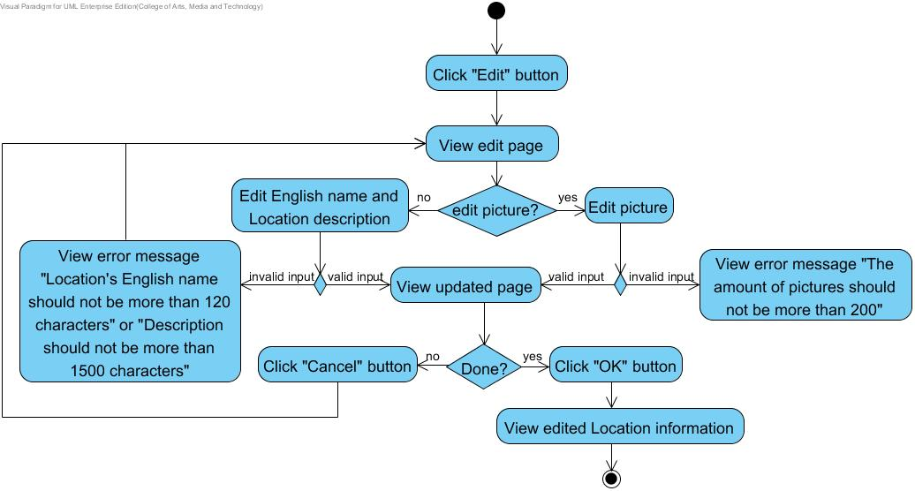

Figure 21: Activity Diagram of “Scan in Travel” AD-15-1

Sub activity diagram (edit picture) of UC-15
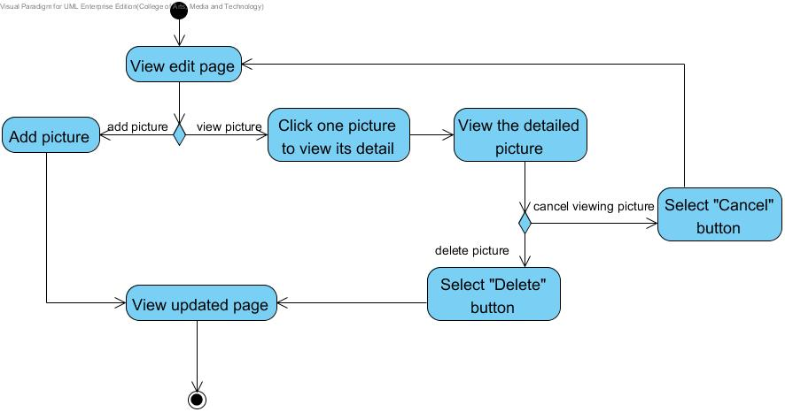

Figure 22: Activity Diagram of “Scan in Travel” AD-15-2

Use Case ID: | UC-16
Use Case Name: | Delete a Location from Favorites
Created By: | Yirui Wang  Ruijuan Liu | Last Updated By: | Yirui Wang  Ruijuan Liu
Date Created: | 15-04-2014 | Last Revision Date: | 03-07-2014
Actors: | Users
Description: | Users can delete a Location from their own Favorites.
Trigger: | Users choose to delete a Location from their own Favorites.
Preconditions: | 1. The service to delete a Location from Favorites is available.  2. Users have added the Location into Favorites successfully.  3. Users have viewed the Location information of selected Location in Favorites successfully.
Post conditions: | System shall delete the data of the selected Location from database.
Normal Flow: | 1. Users choose to delete the selected Location from their own Favorites.  2. System shall provide a control (e.g. button) for users to delete a Location from their own Favorites.  3. Users click “Delete” button.  4. System shall prompt users to confirm the deletion of a selected Location in their own Favorites.  5. System shall provide the user interface to display the prompt message. “Are you sure to delete this Location from Favorites?”  6. Users confirm the deletion of the selected Location.  7. System shall retrieve the data of the selected Location in the database.  8. System shall delete the data of the selected Location from database.  9. System shall provide the user interface to display the Favorites list without deleted Location.  10. Users can view the Favorites list without deleted Location.
Alternative Flows: | In the step 6 of Normal Flow, users can select to cancel the deletion of the selected Location.  1. System shall provide a control (e.g. button) for users to cancel the service of deleting the selected Location.  2. Users select to cancel the service of deleting the selected Location.  3. System shall cancel the service of deleting the selected Location.  4. System shall return to the selected Location information page.  5. Users can view the selected Location information page.  6. Use case ends.
Exceptions: | N/A
Includes: | UC-12, UC-13
Frequency of Use: | Very Frequently
Special Requirements: | The Location whose data are deleted from database must be same as the Location that user select.
Assumptions: | 1. Users understand English language.  2. Users know how to operate smart phones.
Notes and Issues: | 1. The speed of deleting a selected Location from database.  2. The correctness and completeness of the deletion of the selected Location.

Activity Diagram:
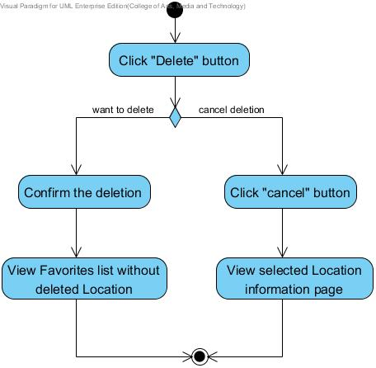

Figure 23: Activity Diagram of “Scan in Travel” AD-16

Use Case ID: | UC-17
Use Case Name: | View the Location on map from Favorites
Created By: | Yirui Wang  Ruijuan Liu | Last Updated By: | Yirui Wang  Ruijuan Liu
Date Created: | 15-04-2014 | Last Revision Date: | 03-07-2014
Actors: | Users  Google Maps API
Description: | Users can view a Location on the map from Favorites list.
Trigger: | Users select to view the selected Location on the map from Favorites.
Preconditions: | Users have selected one Location from Favorites to view the Location information successfully.
Post-conditions: | Users can view the Location on the map.
Normal Flow: | 1. Users choose to view the selected Location on the map.  2. System shall provide a control (e.g. button) for users to view the map of selected Location from Favorites list.  3. Users click “Map” button.  4. System shall send the geometry information (latitude and longitude) of the selected Location to Google Maps API.  5. Google Maps API shall send the information of this Location name to system.  6. System shall receive the map of the selected Location from Google Maps API.  7. System shall provide the user interface to display the selected Location on the map.  8. Users can view the selected Location on the map in the Favorites.
Alternative Flows: | In the step 8 of the Normal Flow, if users want to return to the Location information page.  1. System shall provide a control (e.g. button) to users to return to the previous Location information page.  2. Users choose “Return” button.  3. Use case resumes on the step 2 of Normal Flow.  In the step 8 of the Normal Flow, if users want to view the name of the Location on the map.  1. System shall provide a marker for the Location.  2. Users can click the marker.  3. System shall provide an information window for users to show the Chinese Location name and English Location name of the clicked Location.  4. Users can view the Chinese Location name and English Location name of the Location by click the marker.
Exceptions: | In step 4 of Normal Flow, if there is no internet connection.  1. System shall provide the user interface to display the error message. “No internet connection.”  2. Users can view the error message. “No internet connection.”  3. Use case ends.
Includes: | UC-12, UC-13
Frequency of Use: | Frequently
Special Requirements: | 1. Correctness and expatiation of the map.  2. Correctness and comprehensiveness of the Location catalogue.
Assumptions: | 1. Users understand English.  2. Users knows how to operate smart phones.  3. Users know the basic information about the Location.  4. Users know how to use the electronic map.
Notes and Issues: | 1. What is the proportion of the map?  2. How could the system figure out where users want to look in detail?  3. How could the system figure out how much general users want?

Activity Diagram:
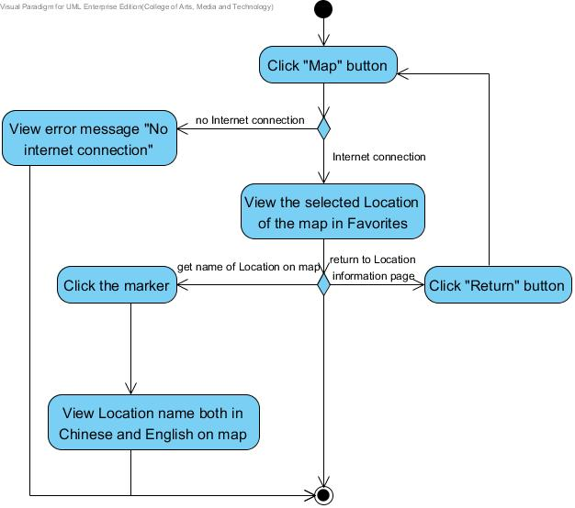

Figure 24: Activity Diagram of “Scan in Travel” AD-17

Use Case ID: | UC-18
Use Case Name: | Sort Locations in Favorites by date
Created By: | Yirui Wang  Ruijuan Liu | Last Updated By: | Yirui Wang  Ruijuan Liu
Date Created: | 15-04-2014 | Last Revision Date: | 03-07-2014
Actors: | Users
Description: | Users can sort the Locations in Favorites by date when they are added.
Trigger: | Users choose to sort Locations in their Favorites by date they are added.
Preconditions: | 1. The service to sort Locations in Favorites by date they are added is available.  2. The system is on running status, and is on the Favorites page.
Post conditions: | System shall provide the user interface to display a list of names of sorted Locations by date. Dates are sorted from the latest to the earliest.
Normal Flow: | 1. Users choose to sort the Locations in their Favorites.  2. System shall provide a control (e.g. button) for users to sort the Locations in Favorites by date they are added.  3. Users click “Sort” button to sort the Locations in Favorites by date they are added.  4. System shall retrieve all the Locations data in their own Favorites from database.  5. System shall sort all the Locations data from database by date they are added.  6. System shall provide the user interface to display a list of names of sorted Locations including both Chinese and English by date. Dates are displayed also and sorted from the latest to the earliest.  7. Users can view a list of names of sorted Locations including both Chinese and English by date.
Alternative Flows: | N/A
Exceptions: | In the step 4 of Normal Flow, there is no Location found in database.  1. System shall provide the user interface to display error message: “No Locations in your Favorites.”  2. Users can view the error message: “No Locations in your Favorites.”  3. Use case ends.
Includes: | N/A
Frequency of Use: | Frequently
Special Requirements: | N/A
Assumptions: | 1. Users understand English language.  2. Users know how to operate smart phones.
Notes and Issues: | 1. The speed of retrieving all Locations from database.  2. The speed of sorting all the Locations by date.  3. The correctness of sorting all the Locations.

Activity Diagram:
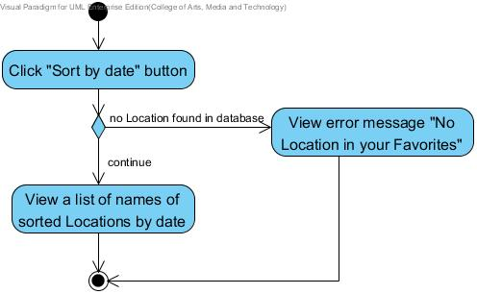

Figure 25: Activity Diagram of “Scan in Travel” AD-18

Use Case ID: | UC-19
Use Case Name: | Sort Locations in Favorites by province name
Created By: | Yirui Wang  Ruijuan Liu | Last Updated By: | Yirui Wang  Ruijuan Liu
Date Created: | 19-04-2014 | Last Revision Date: | 03-07-2014
Actors: | Users
Description: | Users can sort the Locations in Favorites by province name to get a list of province names.
Trigger: | Users select the service to sort Locations in their Favorites by province name.
Preconditions: | 1. The service to sort Locations in Favorites by province name is available.  2. The system is on running status, and is on the Favorites page.
Post conditions: | System shall provide the user interface to display a list of names of sorted Locations by province.
Normal Flow: | 1. Users choose to sort Locations in their Favorites.  2. System shall provide a control (e.g. button) for users to sort the Locations in Favorites by province name.  3. Users click “Sort” button to sort Locations in Favorites by province name.  4. System shall retrieve all the Location data in their own Favorites from database.  5. System shall sort all the provinces related to the Locations in the Favorites.  6. System shall provide the user interface to display a list of province names.  7. System shall provide a popup window to show the prompt message:” Locations sorted by province.”  8. Users can view a list of province names.
Alternative Flows: | N/A
Exceptions: | In the step 4 of Normal Flow, there is no Location found in database.  1. System shall provide the user interface to show prompt message. “No provinces found in Favorites.”  2. Users can view the prompt message. “No provinces found in Favorites.”  3. Use case ends.
Includes: | N/A
Frequency of Use: | Frequently
Special Requirements: | N/A
Assumptions: | 1. Users understand English language.  2. Users know how to operate smart phones.
Notes and Issues: | 1. The speed of retrieving all Locations from database.  2. The speed of sorting all the Locations by province name.  3. The correctness of sorting all the Locations.

Activity Diagram:
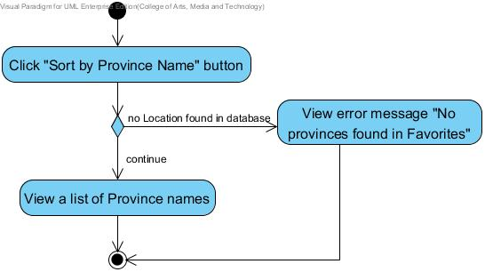

Figure 26: Activity Diagram of “Scan in Travel” AD-19
Use Case ID: | UC-20
Use Case Name: | View the Locations list of one province
Created By: | Yirui Wang  Ruijuan Liu | Last Updated By: | Yirui Wang  Ruijuan Liu
Date Created: | 19-04-2014 | Last Revision Date: | 03-07-2014
Actors: | User
Description: | Users can select one province to view the Locations list in that province.
Trigger: | Users choose to view the Locations of one province in their Favorites.
Preconditions: | 1. The choose view the Locations list of one province in Favorites is available.  2. The system is on running status, and is on the interface which displays the provinces name list from Favorites.  3. Users have viewed the Favorites province list in Favorites successfully.  4. Users added Location into Favorites successfully.
Post conditions: | System shall provide the user interface to display the list of Favorites places from the selected province.
Normal Flow: | 1. Users choose to view the Favorites Locations of one province in their Favorites.  2. System shall provide the service (e.g. Provides the picture for each province) for users to select one province that they want view the Favorites Locations list of the selected province.  3. Users select one province and click the picture of the province.  4. System shall retrieve the Locations data related to the selected province in their own Favorites from database.  5. System shall provide a list of Favorites Locations related to the selected province from Favorites.  6. Users can view the Locations list related to the selected province in Favorites.
Alternative Flows: | In the step 6 of Normal Flow, if users want to view the information of one Location from Favorites Locations list.  1. Users can select a Location to view its information.  2. System shall retrieve the data of the selected Location in the database.  3. System shall provide the user interface for users to view the Location information with Chinese name, English name, pictures, geometry information and description of selected Location in their Favorites.  4. Users can view the Location information with Chinese name, English name, picture, geometry information (latitude and longitude) and description in their favorites.  In the step 6 of the Normal Flow, if users want to return to the previous Favorites provinces list.  1. System shall provide a control (e.g. button) to users to return to the previous Favorites provinces list.  2. Users choose “Return” button.  3. Use case resumes on the step 2 of Normal Flow.
Exceptions: | N/A
Includes: | UC-19
Frequency of Use: | Frequently
Special Requirements: | The Location list of one province from database must be same as the Location that user select.
Assumptions: | 1. Users understand English language.  2. Users know how to operate smart phones.
Notes and Issues: | 1. The speed of retrieving a selected province from database.  2. The correctness and completeness of the data of the selected province.

Activity Diagram:
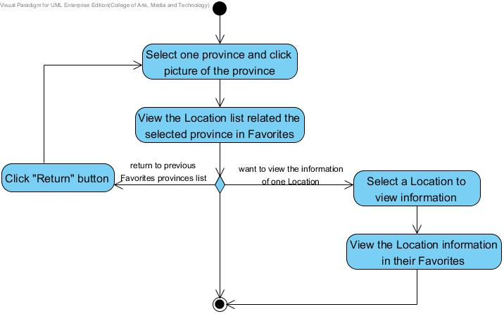

Figure 27: Activity Diagram of “Scan in Travel” AD-20

Use Case ID: | UC-21
Use Case Name: | Sort Locations related to one province by date
Created By: | Yirui Wang  Ruijuan Liu | Last Updated By: | Yirui Wang  Ruijuan Liu
Date Created: | 19-04-2014 | Last Revision Date: | 03-07-2014
Actors: | Users
Description: | Users can sort the Locations list related to one province by date.
Trigger: | Users choose to sort Locations related to one province by date they are added.
Preconditions: | 1. The service to sort Locations related to one province by date they are added is available.  2. The system is on running status, and is on the Favorites places page.
Post conditions: | System shall provide the user interface to display a list of names of sorted Locations by date. Dates are sorted from the latest to the earliest.
Normal Flow: | 1. Users choose to sort the Locations related to one province in their Favorites.  2. System shall provide a control (e.g. button) for users to sort the Locations related to one province by date they are added.  3. Users click “Sort” button to sort the Locations related to the selected province by date they are added.  4. System shall retrieve all the Locations data related to the selected province in their own Favorites from database.  5. System shall sort all the Locations data related to the selected province from database by date they are added.  6. System shall provide the user interface to display a list of names of sorted Locations including both Chinese and English by date. Dates are displayed also and sorted from the latest to the earliest.  7. Users can view a list of names of sorted Locations including both Chinese and English by date.
Alternative Flows: | In the step 7 of the Normal Flow, if users want to return to the previous Favorites provinces list.  1. System shall provide a control (e.g. button) to users to return to the previous Favorites provinces list.  2. Users choose “Return” button.  3. System shall show the Favorites provinces list page.  4. Users can view the Favorites provinces list page.  5. Use case ends.
Exceptions: | N/A
Includes: | UC-19, UC-20
Frequency of Use: | Frequently
Special Requirements: | N/A
Assumptions: | 1. Users understand English language.  2. Users know how to operate smart phones.
Notes and Issues: | 1. The speed of retrieving all Locations related to the selected province from database.  2. The speed of sorting all the Locations by date.  3. The correctness of sorting all the Locations.

Activity Diagram:
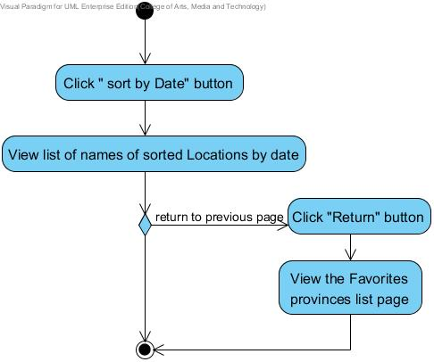

Figure 28: Activity Diagram of “Scan in Travel” AD-21

Use Case ID: | UC-22
Use Case Name: | Sort Locations related to one province alphabetically
Created By: | Yirui Wang  Ruijuan Liu | Last Updated By: | Yirui Wang  Ruijuan Liu
Date Created: | 19-04-2014 | Last Revision Date: | 03-07-2014
Actors: | Users
Description: | Users can sort the Locations list related to one province alphabetically.
Trigger: | Users choose to sort Locations related to one province alphabetically.
Preconditions: | 1. The service to sort Locations related to one province alphabetically is available.  2. The system is on running status, and is on the interface which displays Locations related to one province.
Post conditions: | System shall provide the user interface to display a list of the sorted Locations with their English name and Chinese name alphabetically.
Normal Flow: | 1. Users choose to sort all the Locations related to the selected province alphabetically.  2. System shall provide a control (e.g. button) for users to sort the Locations related to the selected province alphabetically.  3. Users click “Sort” button to sort the Locations related to the selected province alphabetically.  4. System shall retrieve all the Location data related to the selected province in Favorites from database.  5. System shall sort all the Location data from database alphabetically by its English meaning.  6. System shall provide the user interface to display a list of the sorted Locations with their English name and Chinese name alphabetically.  7. Users can view a list of the sorted Locations with their English name and Chinese name alphabetically.
Alternative Flows: | In the step 7 of normal Flow, if users want to view the Locations by alphabetically easily.  1. System shall provide an index bar for users to select the first alphabet of English name of the Location.  2. Users can scroll or tag the index bar to select the first alphabet of English name which they want to view.  3. System shall provide a tag to show the first alphabet that users scrolled.  4. Users can view the selected Location on the screen.  In the step 7 of the Normal Flow, if users want to return to the previous Favorites provinces list.  1. System shall provide a control (e.g. button) to users to return to the previous Favorites provinces list.  2. Users choose “Return” button.  3. System shall show the Favorites provinces list page.  4. Users can view the Favorites provinces list page.  5. Use case ends.
Exceptions: | N/A
Includes: | UC-19, UC-20
Frequency of Use: | Frequently
Special Requirements: | N/A
Assumptions: | 1. Users understand English language.  2. Users know how to operate smart phones.
Notes and Issues: | 1. The speed of retrieving all words in Word book from database.  2. The speed of sorting all the words alphabetically.  3. The correctness of sorting all the words.

Activity Diagram:
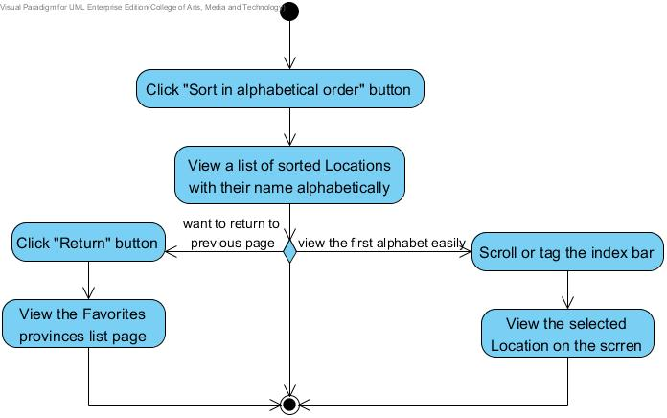

Figure 29: Activity Diagram of “Scan in Travel” AD-22

Use Case ID: | UC-23
Use Case Name: | Search province by English keyword in Favorites
Created By: | Yirui Wang  Ruijuan Liu | Last Updated By: | Yirui Wang  Ruijuan Liu
Date Created: | 20-04-2014 | Last Revision Date: | 03-07-2014
Actors: | Users
Description: | Users can search province by English keyword in the province list.
Trigger: | Users choose to search province in their Favorites by English keyword.
Preconditions: | 1. The service to search province in Favorites by English keyword is available.  2. The system is on running status, and is on the Favorites provinces page.
Post conditions: | System shall provide the user interface to display a (list of) province picture(s) with province name(s) of related province(s).
Normal Flow: | 1. Users choose to search provinces in their Favorites by English keyword.  2. System shall provide a control (e.g. button) for users to search provinces by English keyword in their Favorites.  3. Users click “Search” button.  4. System shall provide the user interface to receive the English keyword inputted by users.  5. Users provide the keyword.  6. System retrieve the data of the province(s) from database by English keyword.  7. System shall provide the user interface to display a (list of) province picture(s) with province name(s) related to the English keyword.  8. Users can view a (list of) province picture(s) with province name(s) related to the English keyword.
Alternative Flows: | N/A
Exceptions: | In the step 5 of Normal Flow, there is no province related to keyword.  1. System shall provide the user interface to display error message: “No province found related to keyword.”  2. Users can view the error message: “No province found related to keyword.”  3. Use case ends.
Includes: | UC-19
Frequency of Use: | Frequently
Special Requirements: | The correctness of the provinces displayed are related to the keyword that users provides.
Assumptions: | 1. Users understand English language.  2. Users know how to operate smart phones.
Notes and Issues: | 1. The algorithm of retrieving all provinces from database by keyword.  2. The correctness of searching the provinces related to the keyword.

Activity Diagram:
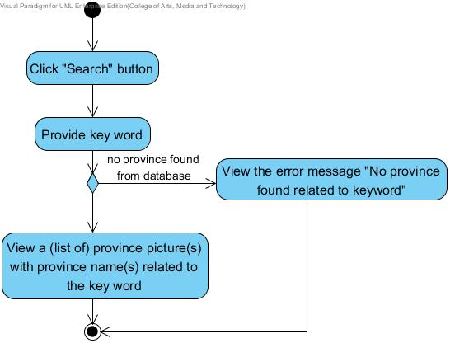

Figure 30: Activity Diagram of “Scan in Travel” AD-23

Use Case ID: | UC-24
Use Case Name: | Search Location by English keyword in Locations list related to one province
Created By: | Yirui Wang  Ruijuan Liu | Last Updated By: | Yirui Wang  Ruijuan Liu
Date Created: | 20-04-2014 | Last Revision Date: | 03-07-2014
Actors: | Users
Description: | Users can search Location by English keyword in the Locations list related to one province.
Trigger: | Users choose to search Location in the Location list related to one province by English keyword.
Preconditions: | 1. The service to search Location in the Locations list related to one province from their Favorites by English keyword is available.  2. The system is on running status, and is on the Favorites places page.
Post conditions: | System shall provide the user interface to display a (list of) name(s) of related Location(s).
Normal Flow: | 1. Users choose to search Location in the Location list related to one province from their Favorites by English keyword.  2. System shall provide a control (e.g. button) for users to search Locations by English keyword in their Favorites.  3. Users click “Search” button.  4. System shall provide the user interface to receive the English keyword inputted by users.  5. Users provide the keyword.  6. System retrieve the data of the Location(s) from database by English keyword.  7. System shall provide the user interface to display a (list of) Location name(s) related to the English keyword.  8. Users can view a (list of) Location name(s) with related to the English keyword.
Alternative Flows: | In the step 8 of the Normal Flow, if users want to return to the previous Favorites provinces list.  1. System shall provide a control (e.g. button) to users to return to the previous Favorites provinces list.  2. Users choose “Return” button.  3. System shall show the Favorites provinces list page.  4. Users can view the Favorites provinces list page.  5. Use case ends.
Exceptions: | In the step 5 of Normal Flow, there is no Locations related to keyword.  1. System shall provide the user interface to display error message: “No location found related to keyword.”  2. Users can view the error message: “No location found related to keyword.”  3. Use case ends.
Includes: | UC-19, UC-20
Frequency of Use: | Frequently
Special Requirements: | The correctness of the Locations displayed are related to the keyword that users provides.
Assumptions: | 1. Users understand English language.  2. Users know how to operate smart phones.
Notes and Issues: | 1. The algorithm of retrieving all Locations related to the selected province from database by keyword.  2. The correctness of searching the Locations related to the keyword.

Activity Diagram:
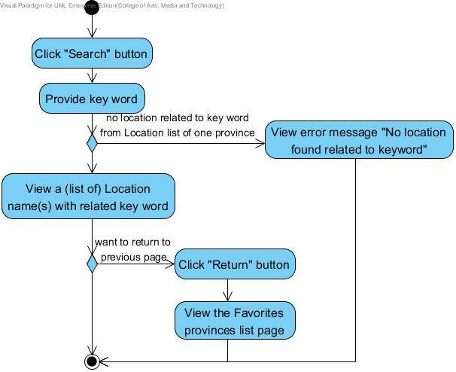

Figure 31: Activity Diagram of “Scan in Travel” AD-24

Use Case ID: | UC-25
Use Case Name: | Search Locations by English keyword in Favorites
Created By: | Yirui Wang  Ruijuan Liu | Last Updated By: | Yirui Wang  Ruijuan Liu
Date Created: | 20-04-2014 | Last Revision Date: | 03-07-2014
Actors: | Users
Description: | Users can search Locations by English keyword from all the Locations in their Favorites.
Trigger: | Users choose to search Locations in their Favorites by English keyword.
Preconditions: | 1. The service to search Locations in Favorites by English keyword is available.  2. The system is on running status, and is on the Favorites page.
Post conditions: | System shall provide the user interface to display a (list of) name(s) of related Location(s).
Normal Flow: | 1. Users choose to search Locations in their Favorites by English keyword.  2. System shall provide a control (e.g. button) for users to search Locations by English keyword in their Favorites.  3. Users click “Search” button.  4. System shall provide the user interface to receive the English keyword inputted by users.  5. Users provide the keyword.  6. System retrieve the data of the Location(s) from database by English keyword.  7. System shall provide the user interface to display a (list of) name(s) of Location(s) related to the English keyword.  8. Users can view a (list of) name(s) of Location(s) related to the English keyword.
Alternative Flows: | N/A
Exceptions: | In the step 5 of Normal Flow, there is no Location in database.  1. System shall provide the user interface to display error message: “No Locations in your Favorites.”  2. Users can view the error message: “No Locations in your Favorites.”  3. Use case ends.  In the step 7 of Normal Flow, if there is no Location related to keyword.  1. System shall provide the user interface to display the error message: “No locations found related to keyword.”  2. Users can view the error message: “No locations found related to keyword.”  3. Use case ends.
Includes: | N/A
Frequency of Use: | Frequently
Special Requirements: | The correctness of the Locations displayed are related to the keyword that users provides.
Assumptions: | 1. Users understand English language.  2. Users know how to operate smart phones.
Notes and Issues: | 1. The algorithm of retrieving all Locations from database by keyword.  2. The correctness of searching the Locations related to the keyword.

Activity Diagram:
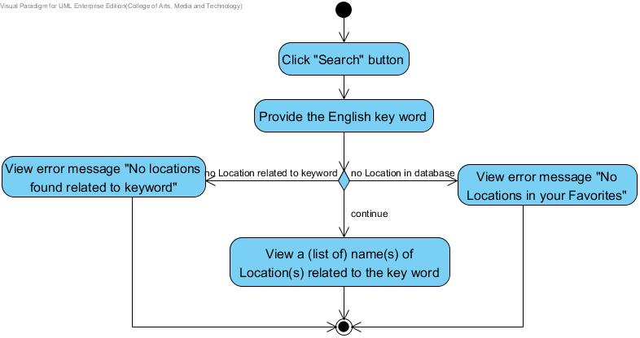

Figure 32: Activity Diagram of “Scan in Travel” AD-25

Use Case ID: | UC-26
Use Case Name: | View home page
Created By: | Yirui Wang  Ruijuan Liu | Last Updated By: | Yirui Wang  Ruijuan Liu
Date Created: | 20-04-2014 | Last Revision Date: | 03-07-2014
Actors: | Users
Description: | Users can view the home page.
Trigger: | Users choose to view the home page.
Preconditions: | Users start the ‘Scan in Travel’ application.
Post-conditions: | System shall provide the user interface for users to view the home page.
Normal Flow: | 1. Users choose to view the home page.  2. System shall provide a control (e.g. button) for users to view the home page.  3. Users click “Home” button.  4. System shall provide the user interface for users to view the home page.  5. Users can view the home page.
Alternative Flows: | N/A
Exceptions: | N/A
Includes: | N/A
Frequency of Use: | Very Frequently
Special Requirements: | N/A
Assumptions: | - Users understand English.  - Users know how to operate the smart phone.
Notes and Issues: | N/A

Activity Diagram:
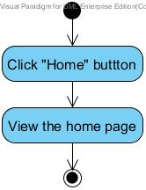

Figure 33: Activity Diagram of “Scan in Travel” AD-26

4.2.4 Feature Name
Word book system

4.2.4.1 Feature Process Flow
After users get the English meaning of the scanned Chinese words, they can save the scanned words with English translation to their own Word book. When users are viewing the word list in their Word book, they can sort words alphabetically or by date when words are added. Users can also search the words by keyword related to their English meaning. Moreover, users can select the text-to-speech function to listen to the pronunciation of the selected Chinese word(s). Moreover, users can make their own note to each word that they save in their Word book.

4.2.4.2 Use Case(s)

Use Case ID: | UC-27
Use Case Name: | Add scanned words into Word book
Created By: | Yirui Wang  Ruijuan Liu | Last Updated By: | Yirui Wang  Ruijuan Liu
Date Created: | 20-04-2014 | Last Revision Date: | 03-07-2014
Actors: | Users
Description: | Users can add the scanned words into their own Word book.
Trigger: | Users choose to add the scanned words into Word book.
Preconditions: | 1. The service to add the scanned words into Word book is available.  2. The system is on running status, and is on the interface which displays the scanned word.
Post conditions: | System adds the scanned word into database.
Normal Flow: | - Users choose to add this scanned word into Word book.  - System shall provide a control (e.g. button) for users to add the scanned word into Word book.  - Users can click “add to Word book” button.  4. System shall retrieve all the word data in Word book from database.  5. System shall add the scanned word into database.  6. System shall provide a dialog to display the successful message: “Word is added successfully!” and provides a control (e.g. button) for users to close the dialog.  7. Users can view the successful message: “Word is added successfully!”
Alternative Flows: | In the step 6 of Normal Flow, if users want to view the Word book after they add the new word.  1. System shall provide a control (e.g. button) for users to view the Word book after they add the new Word.  2. Users can click “View Word Book” button.  3. System shall show the interface of Word book.  4. Users can view the Word book.
Exceptions: | In the step 4 of Normal Flow, there is an existed word which is same as the scanned word.  1. System shall provide the user interface to display the error message. “Word exists already.”  2. Users can view the error message. “Word exists already.”  3. Use case ends.  In the step 3 of Normal Flow, if system did not show the  English explanation of scanned word.  - System shall show a dialog to display the error message: “Please wait for the explanation.”  - Users can view the error message: “Please wait for the explanation.”  - Users click “ok” button.  - Use case resumes on the step 2 of Normal Flow.
Includes: | UC-01, UC-02
Frequency of Use: | Very Frequently
Special Requirements: | The word that is added into Word book is same as the scanned one.
Assumptions: | 1. Users understand English language.  2. Users know how to operate smart phones.
Notes and Issues: | 1. The speed of adding the scanned word into Word book.  2. The correctness of adding the scanned word into Word book.

Activity Diagram:
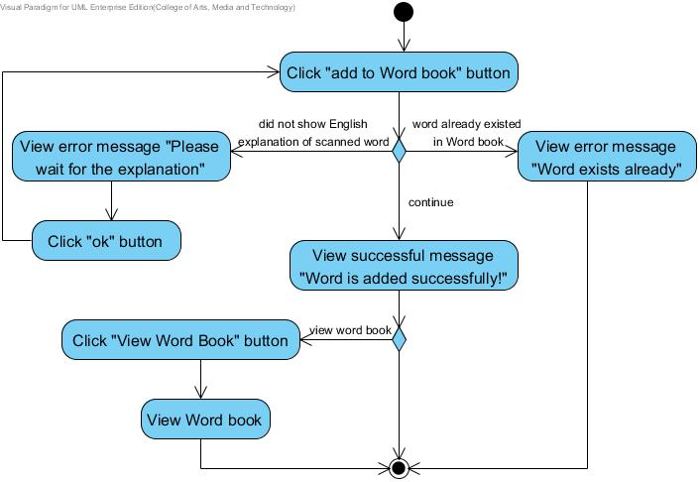
Figure 34: Activity Diagram of “Scan in Travel” AD-27

Use Case ID: | UC-28
Use Case Name: | View Chinese words list in Word book
Created By: | Yirui Wang  Ruijuan Liu | Last Updated By: | Yirui Wang  Ruijuan Liu
Date Created: | 22-04-2014 | Last Revision Date: | 03-07-2014
Actors: | Users
Description: | Users can view a Chinese word list with its English meaning and added date in their Word book.
Trigger: | Users choose to view a Chinese word list with its English meaning and added date in Word book.
Preconditions: | 1. The service to view a Chinese word with its related information in Word book is available.  2. Users are on the Word book page.
Post conditions: | System shall provide the user interface to display the list of Chinese words and related English name, added date in their own Word book.
Normal Flow: | - Users choose to view the Chinese word list in Word book.  - System shall provide a control (e.g. button) for users to view the Word book.  - Users can click “Word book” button.  4. System shall retrieve all the word data in Word book from database.  5. System shall provide the user interface displaying all the words with its English meaning and added date from database in one list.  6. Users can view a Chinese word list with its English meaning and added date in their Word book.
Alternative Flows: | N/A
Exceptions: | In the step 3 of Normal Flow, there is no word found from Word book in database.  1. System shall provide the user interface to show prompt message. “No word in Word Book.”.  2. Users can view the prompt message. “No word in Word Book.”.  3. Use case ends.
Includes: | UC-27
Frequency of Use: | Very Frequently
Special Requirements: | Correctness and comprehensiveness of Words.
Assumptions: | 1. Users understand English language.  2. Users know how to operate smart phones.
Notes and Issues: | 1. The speed of retrieving the Words list in Word book from database.  2. The correctness of the Word book.

Activity Diagram:
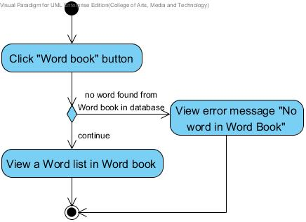

Figure 35: Activity Diagram of “Scan in Travel” AD-28
Use Case ID: | UC-29
Use Case Name: | View a Chinese word and related information in Word book
Created By: | Yirui Wang  Ruijuan Liu | Last Updated By: | Yirui Wang  Ruijuan Liu
Date Created: | 22-04-2014 | Last Revision Date: | 03-07-2014
Actors: | Users
Description: | Users can select one Chinese word from word list to view the Chinese words and related information.
Trigger: | Users select a word from Word list to view the Chinese word with its related information in Word book.
Preconditions: | 1. The service to view a Chinese word with its related information in Word book is available.  2. The system is on running status, and has opened Word book already.  3. There is at least one word existed in Word book already.
Post conditions: | System shall provide the user interface to display the selected Chinese word and related information in their own Word book.
Normal Flow: | 1. Users select a word from Word list to view the Chinese word with its related information in Word book.  2. System shall retrieve the data of the selected word in Word book from database.  3. System shall provide the user interface displaying the Chinese word and English meaning of the selected word from database.  4. Users can view the selected Chinese word with its Chinese word and English meaning.
Alternative Flows: | In the step 4 of the Normal Flow, if users want to return to the previous Word list.  1. System shall provide a control (e.g. button) to users to return to the previous Word list.  2. Users choose “Return” button.  3. Use case ends.
Exceptions: | N/A
Includes: | UC-28
Frequency of Use: | Very Frequently
Special Requirements: | The word that is viewed with its related information in Word book is same as the selected one.
Assumptions: | 1. Users understand English language.  2. Users know how to operate smart phones.
Notes and Issues: | 1. The speed of retrieving the selected word in Word book from database.  2. The correctness of the selected word in Word book.  3. The completeness of the information related to the selected word.

Activity Diagram:
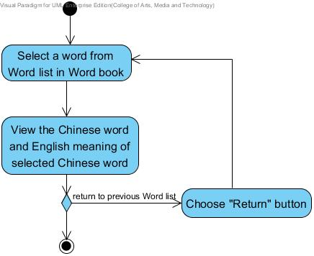

Figure 36: Activity Diagram of “Scan in Travel” AD-29

Use Case ID: | UC-30
Use Case Name: | Get the pronunciation of a Chinese word in Word book
Created By: | Yirui Wang  Ruijuan Liu | Last Updated By: | Yirui Wang  Ruijuan Liu
Date Created: | 22-04-2014 | Last Revision Date: | 03-07-2014
Actors: | Users  Microsoft Translator API
Description: | Users can select Text-To-Speech to get the pronunciation of a Chinese word in their Word book.
Trigger: | Users choose to get the pronunciation of a Chinese word in Word book.
Preconditions: | 1. The service to get the pronunciation of a Chinese word in Word book is available.  2. The system is on running status, and is on the interface which displays a Chinese word from Word book.
Post conditions: | Users get the proper pronunciation of the selected Chinese word.
Normal Flow: | 1. Users choose to get the pronunciation of a Chinese word in Word book.  2. System shall provide a control (e.g. button) for users to request for the proper pronunciation of a Chinese word in their Word book.  3. Users click speak button to requests the pronunciation of the selected Chinese word.  4. System shall send the selected Chinese word to Microsoft Translator API.  5. Microsoft Translator API shall retrieve the pronunciation data of the word.  6. Microsoft Translator API shall send the pronunciation data to system.  7. System shall receive the pronunciation of the selected word in Chinese.  8. System shall pronounce the selected Chinese word.  9. Users get the proper pronunciation of the selected Chinese word.
Alternative Flows: | N/A
Exceptions: | In the step 4 of Normal Flow, there is no internet connection.  1. System shall provide the user interface to display the error message. “No internet connection.”  2. Users can view the error message. “No internet connection.”  3. Use case ends.
Includes: | UC-28, UC-29
Frequency of Use: | Frequently
Special Requirements: | N/A
Assumptions: | 1. Users understand English language.  2. Users know how to operate smart phones.  3. Smart phone owns built-in speaker.
Notes and Issues: | 1. The speed of requesting and receiving the pronunciation of the selected Chinese word from Microsoft Translator API.  2. The correctness of pronunciation provided by Microsoft Translator API.

Activity Diagram:
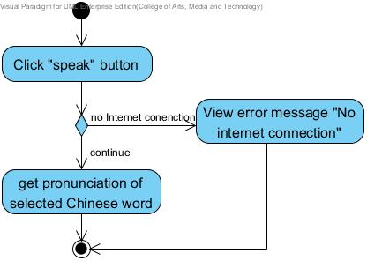
Figure 37: Activity Diagram of “Scan in Travel” AD-30
Use Case ID: | UC-31
Use Case Name: | Delete a word from Word book
Created By: | Yirui Wang  Ruijuan Liu | Last Updated By: | Yirui Wang  Ruijuan Liu
Date Created: | 24-04-2014 | Last Revision Date: | 03-07-2014
Actors: | Users
Description: | Users can delete a word from their own Word book.
Trigger: | Users choose to delete a word from Word book.
Preconditions: | 1. The service to delete a word from Word book is available.  2. Users have added word into Word book before.  3. The system is on running status, and has opened one Word information from Word book already.
Post conditions: | System shall delete the data of the selected word from database.
Normal Flow: | 1. Users choose to delete a word from their own Word book.  2. System shall provide a control (e.g. button) for users to delete a word from Word book.  3. Users can click “Delete” button.  4. System shall provide the user interface for users to display the prompt message:” Are you sure to delete this word from Word book? ”.  5. Users confirms the deletion.  6. System shall retrieve all the word data in Word book from database.  7. System shall delete the data of the selected word from database.  8. System shall provide the user interface to display the Words list without deleted word.  9. Users can view the Words list without deleted word.
Alternative Flows: | In the step 5 of Normal Flow, users can select to cancel the deletion.  1. System shall provide the service for users to cancel the service of deleting the selected word.  2. Users select to cancel the deletion.  3. System shall cancel the service of deleting the selected word.  4. Use case resumes on the Step 2 of Normal Flow.
Exceptions: | N/A
Includes: | UC-28, UC-29
Frequency of Use: | Frequently
Special Requirements: | 1. The word that is deleted from Word book is same as the selected one.  2. System shall delete all the data of the selected word from database.
Assumptions: | 1. Users understand English language.  2. Users know how to operate smart phones.
Notes and Issues: | 1. The speed of deleting the selected word from Word book.  2. What kind of data of the selected word would be deleted?

Activity Diagram:
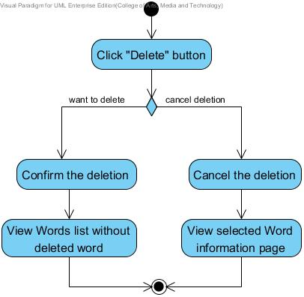

Figure 38: Activity Diagram of “Scan in Travel” AD-31

Use Case ID: | UC-32
Use Case Name: | Sort words in Word book by date
Created By: | Yirui Wang  Ruijuan Liu | Last Updated By: | Yirui Wang  Ruijuan Liu
Date Created: | 24-04-2014 | Last Revision Date: | 03-07-2014
Actors: | Users
Description: | Users can sort the words in their Word book by date when they are added.
Trigger: | Users choose to sort words in Word book by date when they are added.
Preconditions: | 1. The service to sort words in Word book by date when they are added is available.  2. The system is on running status, and is on the Word book page.
Post conditions: | System shall provide the user interface to display a list of the sorted Chinese words with its English meaning by date. Dates are sorted from the latest to the earliest.
Normal Flow: | 1. Users choose to sort words in Word book.  2. System shall provide a control (e.g. button) for users to sort the words in their Word book by date when they are added.  3. Users click “Sort” button to sort the words in Word book by date when they are added.  4. System shall retrieve all the word data in Word book from database.  5. System shall sort all the words data from database by date they are added.  6. System shall provide the user interface to display a list of the sorted Chinese words with its English meaning by date. Dates are also displayed and sorted from the latest to the earliest.  7. Users can view a list of the sorted Chinese words with its English meaning by date.
Alternative Flows: | N/A
Exceptions: | In the step 4 of Normal Flow, there is no word found in Word book from database.  1. System shall provide the user interface to show prompt message. “No word in Word Book.”.  2. Users can view the prompt message. “No word in Word Book.”.  3. Use case ends.
Includes: | UC-28
Frequency of Use: | Very Frequently
Special Requirements: | N/A
Assumptions: | 1. Users understand English language.  2. Users know how to operate smart phones.
Notes and Issues: | 1. The speed of retrieving all words in Word book from database.  2. The speed of sorting all the words by date that they are added.  3. The correctness of sorting all the words.

Activity Diagram:
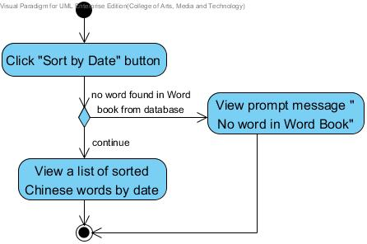

Figure 39: Activity Diagram of “Scan in Travel” AD-32
Use Case ID: | UC-33
Use Case Name: | Sort words in Word book alphabetically
Created By: | Yirui Wang  Ruijuan Liu | Last Updated By: | Yirui Wang  Ruijuan Liu
Date Created: | 25-04-2014 | Last Revision Date: | 03-07-2014
Actors: | Users
Description: | Users can sort the words in their Word book alphabetically.
Trigger: | Users choose to sort words in Word book alphabetically.
Preconditions: | 1. The service to sort words in Word book alphabetically is available.  2. The system is on running status, and is on the interface which displays words from Word book.  3. There is Word existed in Word book already.
Post conditions: | System shall provide the user interface to display a list of the sorted Chinese words with their English meaning.
Normal Flow: | 1. Users choose to sort words in Word book alphabetically.  2. System shall provide a control (e.g. button) for users to sort the words in their Word book alphabetically.  3. Users click “Sort” button to sort the words in Word book alphabetically.  4. System shall retrieve all the word data in Word book from database.  5. System shall sort all the word data from database alphabetically by its English meaning.  6. System shall provide the user interface to display a list of the sorted Chinese words with their English meaning alphabetically.  7. Users can view a list of the sorted Chinese words with their English meaning in Word Book alphabetically.
Alternative Flows: | In the step 7 of normal Flow, if users want to view the words by alphabetically easily.  1. System shall provide a index bar for users to select the first alphabet of English meaning of the word.  2. Users can scroll or tag the index bar to select the first alphabet of English meaning which they want to view.  3. System shall provide a tag to show the first alphabet that users scrolled.  4. Users can view the selected word on the screen.
Exceptions: | In the step 4 of Normal Flow, there is no word found in Word book from database.  1. System shall provide the user interface to show prompt message. “No word in Word Book.”.  2. Users can view the prompt message. “No word in Word Book.”.  3. Use case ends.
Includes: | UC-28
Frequency of Use: | Frequently
Special Requirements: | N/A
Assumptions: | 1. Users understand English language.  2. Users know how to operate smart phones.
Notes and Issues: | 1. The speed of retrieving all words in Word book from database.  2. The speed of sorting all the words alphabetically.  3. The correctness of sorting all the words.

Activity Diagram:
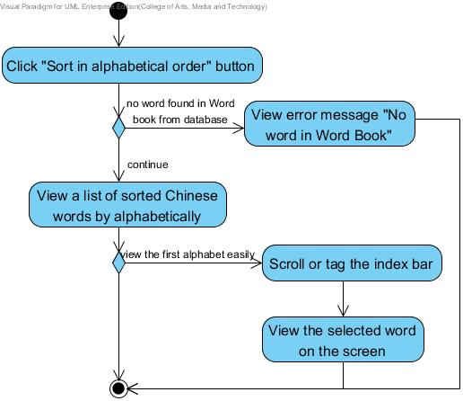
Figure 40: Activity Diagram of “Scan in Travel” AD-33

Use Case ID: | UC-34
Use Case Name: | Search Chinese words in Word book
Created By: | Yirui Wang  Ruijuan Liu | Last Updated By: | Yirui Wang  Ruijuan Liu
Date Created: | 25-04-2014 | Last Revision Date: | 03-07-2014
Actors: | Users
Description: | Users can search Chinese words in the Word book by their meaning in English.
Trigger: | Users choose to search Chinese words in Word book by their meaning in English.
Preconditions: | 1. The service to search Chinese words in Word book is available.  2. The system is on running status, and has opened Word book already.
Post conditions: | System shall provide the user interface to display a (list of) related word(s).
Normal Flow: | 1. Users choose to search Chinese words in Word book by their meaning in English.  2. System shall provide a control (e.g. button) for users to search Chinese words in the Word book by their meaning in English.  3. Users click “Search” button.  4. System shall provide the user interface to receive the English meaning inputted by users.  5. Users provide the English meaning for searching Chinese word(s).  6. System retrieve the data of the word(s) from database by the English meaning.  7. System shall provide the user interface to display a (list of) word(s) related to the received English meaning.  8. Uses can view a list of words related to the searched English meaning.
Alternative Flows: | N/A
Exceptions: | In the step 8 of Normal Flow, there is no word found in Word book from database.  1. System shall provide the user interface to show prompt message. “No word in Word Book.”.  2. Users can view the prompt message. “No word in Word Book.”.  3. Use case ends.  In the step 8 of Normal Flow, there is no word found which is related to the English meaning provided by users in Word book from database  1. System shall provide the user interface to display the error message. “No word found related to the keyword.”  2. Users can view the error message. “No word found related to the keyword.”  3. Use case ends.
Includes: | UC-28
Frequency of Use: | Frequently
Special Requirements: | Any words related to the English meaning that users provides must be displayed.
Assumptions: | 1. Users understand English language.  2. Users know how to operate smart phones.
Notes and Issues: | 1. The speed of retrieving all words in Word book from database by the meaning.  2. The correctness of retrieving the words in Word book from database by the meaning.  3. Any words related to the English meaning that users provide must be retrieved.

Activity Diagram:
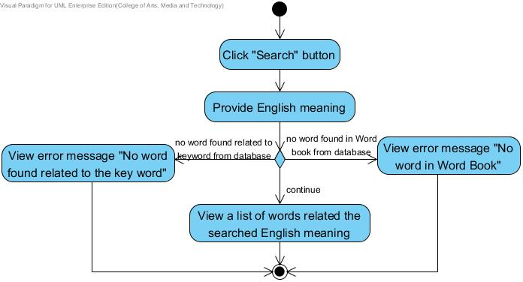

Figure 41: Activity Diagram of “Scan in Travel” AD-34

Use Case ID: | UC-35
Use Case Name: | Make note to the word in Word book
Created By: | Yirui Wang  Ruijuan Liu | Last Updated By: | Yirui Wang  Ruijuan Liu
Date Created: | 25-07-2014 | Last Revision Date: | 28-07-2014
Actors: | Users
Description: | Users can make their own note to each word in their Word book.
Trigger: | Users select the service to make the note to the selected word in their own Word book.
Preconditions: | 1. The service to make the note is available.  2. The system is on running status, and is on the interface which displays the selected word from the list in Word book.
Post conditions: | System shall update the note of the selected word into database.
Normal Flow: | 1. Users choose to make the note to the selected word in their own Word book.  2. System shall provide a service for users to make the note of the selected word.  3. Users click the hint “Add your note here” in the edit box.  4. System shall provide the user interface to receive the data from users to make the note.  5. Users make the note to the selected word.  6. Users click “√” button to save the updated note.  7. System shall update the note data provided by users in database.  8. System shall provide the user interface to display the updated note of selected word.  9. Users view the updated note of the selected word.
Alternative Flows: | In the step 5 of Normal Flow, users can select to cancel the service of making the note to the selected word.  1. System shall provide a control (e.g. button) for users to cancel the service of making the note.  2. Users click “X” button to cancel the service of making the note.  3. System shall cancel the service of making the note.  4. Use case ends. (Use case resumes on the UC-29, system shall return to the selected word page).  In the step 5 of Normal Flow, users can delete the note content of the selected word.  1. Users delete the note content of the selected word.  2. System shall display the hint “Add your note here” in the edit area.  3. Use case resumes on step 6 of Normal Flow.  In the step 9 of Normal Flow, if users want to edit the note of the selected word.  1. System shall provide a control (e.g. button) for users to edit the note of the selected word.  2. Users click “edit” button.  3. System shall provide the user interface to receive the data provided by users to edit the note.  4. Users edit the note of the selected word.  5. Use case resumes on step 6 of Normal Flow.
Exceptions: | In the step 5 of Normal Flow, the length of the note that users provide is more than 1500 characters.  1. System shall provide the user interface to display the error message. “Note should not be more than 1500 characters.”  2. Users view the error message. “Note should not be more than 1500 characters.”  3. Users can not add more character in edit area.  4. Use case resumes on step 6 of Normal Flow.
Includes: | UC-28, UC-29
Frequency of Use: | Frequently
Special Requirements: | The note of the selected word that are stored in database should be same as the  note that users provide.
Assumptions: | 1. Users understand English language.  2. Users know how to operate smart phones.  3. Users know how to key the text on smart phones.
Notes and Issues: | 1. The speed of updating the note in the database.  2. The completeness of note of the selected word which are added to database.

Activity Diagram:
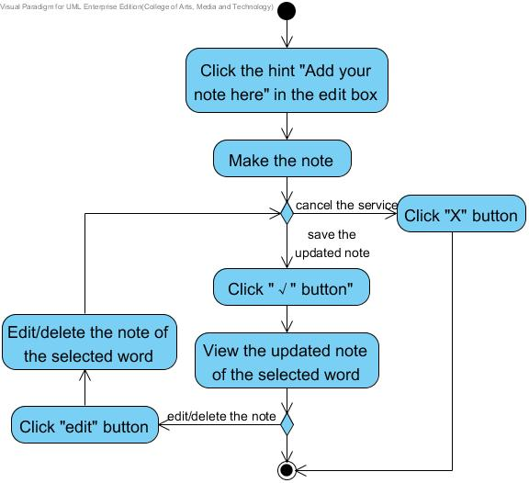

Figure 42: Activity Diagram of “Scan in Travel” AD-35

Use Case ID: | UC-36
Use Case Name: | View help information
Created By: | Yirui Wang  Ruijuan Liu | Last Updated By: | Yirui Wang  Ruijuan Liu
Date Created: | 25-04-2014 | Last Revision Date: | 03-07-2014
Actors: | Users
Description: | Users can view help information.
Trigger: | Users choose to view the home page.
Preconditions: | Users start the ‘Scan in Travel’ application.
Post-conditions: | System shall provide the user interface for users to view the help information.
Normal Flow: | 1. Users choose to view the help information.  2. System shall provide a control (e.g. button) for users to view the help information.  3. Users click “Help” button.  4. System shall provide the user interface for users to view the help information.  5. Users can view the help information which includes application introduction and main features description.
Alternative Flows: | In the step 4 of the Normal Flow, if users want to close the help information page.  1. System shall provide a control (e.g. button) to users to close the help information page.  2. Users choose “X” button.  3. System shall return to the previous viewing page.  4. Users can view the previous viewing page.  5. Use case ends.
Exceptions: | N/A
Includes: | N/A
Frequency of Use: | Frequently
Special Requirements: | N/A
Assumptions: | 1. Users understand English.  2. Users know how to operate the smart phone.
Notes and Issues: | N/A

Activity Diagram:
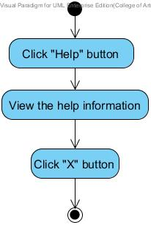
Figure 43: Activity Diagram of “Scan in Travel” AD-36

Chapter Five | Reference

[1] Definition of User Interface
http://searchsoa.techtarget.com/definition/user-interface

[2] Definition of UML
http://en.wikipedia.org/wiki/Unified_Modeling_Language

[3] Definition of Activity Diagram
http://en.wikipedia.org/wiki/Activity_diagram

[4] Definition of Use Case
http://searchsoftwarequality.techtarget.com/definition/use-case

[5] Definition of Use Case Diagram
http://en.wikipedia.org/wiki/Use_Case_Diagram

